## 

**Durian Store**

**(Mobile Online Shop)**

**Software Requirement Specification**



– Hanoi, May 2023 –

**Table of Contents**

**I. Introduction** **4**

1. Overview 4

2. Purpose 4

3. Scope 4

4. Environment 5

5. Definitions, Acronyms, and Abbreviations 5

Definitions 5

Acronyms, and Abbreviations 5

**II. General Description** **5**

1. Product specification 5

2. Product Functions 6

3. User functions 6

3.1 Guest 6

3.2 Registered Users 6

3.3 Admin 7

4. Context diagrams 7

5. System functions 7

5.1 Screen flow 7

5.2 Screen details 7

5.3 User Authorization 9

6. Entity relationship diagram 9

7. General Constraints 9

Naming convention: 9

Architectural Constraints: 10

Web Standards Constraint: 10

**III. Specific Requirements** **10**

1. Requires external interface 10

1.1 User Interface 10

1.2 Hardware Interface 11

1.3 Software interface 11

2. Use Cases 11

2.1 Use Case Overview 11

2.2 Use Case Guest 12

2.3 Use Case User 14

2.4 Use Case Admin 16

3. Functional Requirements 18

3.1 View Home 19

3.2 Sign in account 19

3.3 Sign-up 21

3.4 Product List 22

3.5 Product Details 23

3.6 Forgot password 25

3.7 Filter Product 26

3.8 Search Product 27

3.9 Paging 28

3.10 Change Password 28

3.11 Admin manager page 29

3.12 Remove product 30

3.13 Change content 31

3.14 Update profile 32

3.15 Update product 33

3.16 Account profile 34

3.17 Add product 35

**IV. Appendices** **37**

1. Business rule 37

2. Kanban Table 37

3. Burndown Chart 38

4. Road map of Iter 2 38

# **I. Introduction**

## 1. Overview

The purpose of this document is to outline the requirements for developing a website for an iPhone store. The website will serve as a platform for customers to browse and transact for available iPhone models at the store.

## 2. Purpose

The objective of this website is to provide an online store where customers can conveniently find and purchase iPhones. The website must offer a user-friendly interface, secure transactions, and filtering capabilities.

## 3. Scope

* The Durian Store is an e-commerce platform specifically designed for selling iphones.
* The system allows guests, users to browse and see details for various iPhone models, view detailed product information, and make purchases online.
* Guests can sign-up and create accounts so they can sign-in the system. Users can manage their profile information, track order history, and comments.
* The system provides features for users to add products to their shopping cart, proceed to checkout, and check the shipping status.
* The system includes an administrative interface for administrators to manage products, view orders, manage comments and profile of users.
* The language of the Durian Store includes the front-end interface (Html, Css, Js), back-end (Java) functionality, and database (SQL Server) management necessary to support the core features and operations of the online shop.

## 4. Environment

| **Software** | **Version** |
| --- | --- |
| Microsoft SQL Server | 2019 |
| Netbeans | 13 |
| Java Development Kit | 8.0.203 |
| Google Chrome | 113.0.5672.93 |
| Apache Tomcat | 10 |

## 5. Definitions, Acronyms, and Abbreviations

| Definitions | Acronyms, and Abbreviations |
| --- | --- |
| SRS | Software Requirements Specifications |
| BR | Business Rule |
| UI | User Interface |
| UC | Use Case |
| N/A | Not applicable, not available |

# **II. General Description**

## 

## 1. Product specification

* **Durian Store** is an online store specializing in providing all kinds of Iphone running iOS operating system. A website-based application for users to purchase online, allowing customers to directly place orders and purchase goods at the website itself, while helping to improve the customer experience.
* **Coming to the Durian Store,** we can see the open and easy-to-see interface. The website offers products with its basic features that are inferior to the color, value in the market. Durian Store built an admin function to be able to manage the list of all products in the store, besides also managing user accounts, comments (reviews) and orders.
* With many attractive features, the interface of a Durian Store is more than a regular website, it is a product management system that you want.

Full and clear product information ✓

Review from others users ✓

## 2. Product Functions

* Product detail: provides detailed information and description about a specific product including product image, description, price, colors, storage and reviews. The product detail page is displayed after the user clicks on a product in the product list.
* Sign in and Sign up: allows guests to create accounts, sign-in the website and manage personal information.
* Product page: Displays products with images, titles,colors, storage and prices. Bring all the products in the displayed database to the screen.
* Forgot password: allows the user to recover the password of the account when the user does not remember the current password, providing the user with some security questions.

## 3. User functions

### 3.1 Guest

* When the user has not registered for an account they can view the product list, detailed information of each product, and view comments.
* In the feature that allows guests to add products to the cart but can’t checkout.

### 3.2 Registered Customers

* Once created, the user will inherit the guest features and have access to many other functions in the system.
* Can proceed to order for products.
* Users can write a comment and rating about the product.
* Manage your personal information in your account, update and change when necessary.
* Can track their order status.

### 3.3 Admin

* Manage and operate the entire website operation, have access to and control the features and information on the website.
* Product management: can add, edit and delete products.
* Order management: Admin can view and manage all orders placed. Update order status and track shipping...
* User account management: Modify user role, handle account-related issues.
* Customer support: Consulting to resolve customer inquiries and complaints about products.

Durian Store has 3 different types of users, including guest users, registered users, and administrators. Each type of user has different privileges, access levels, and capabilities in the system, tailored to their specific needs and responsibilities.

## 4. Context diagrams

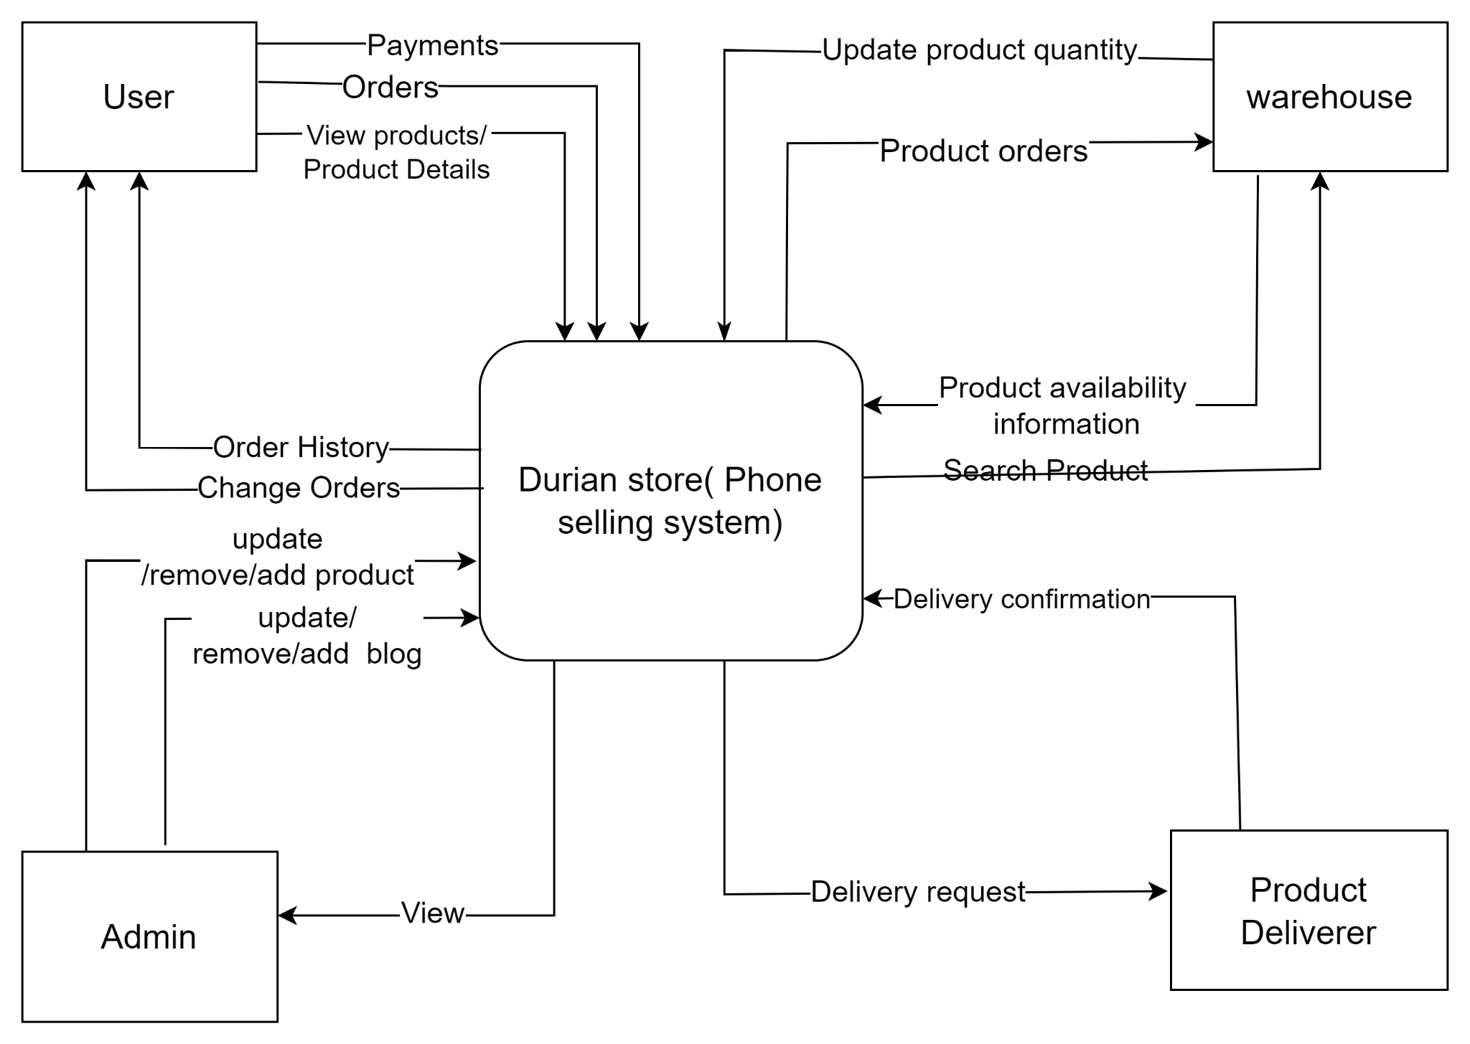

## 

## 5. Business rich picture

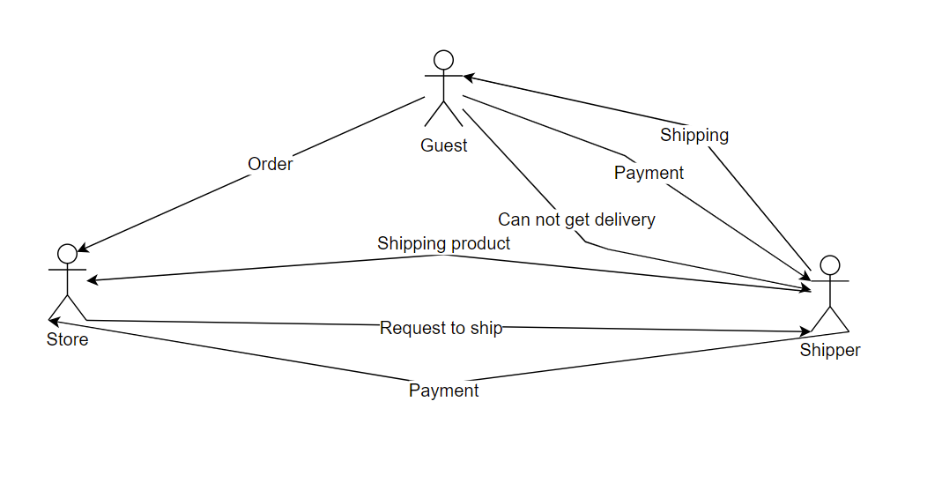

## 6. System functions

### 6.1 Screen flow

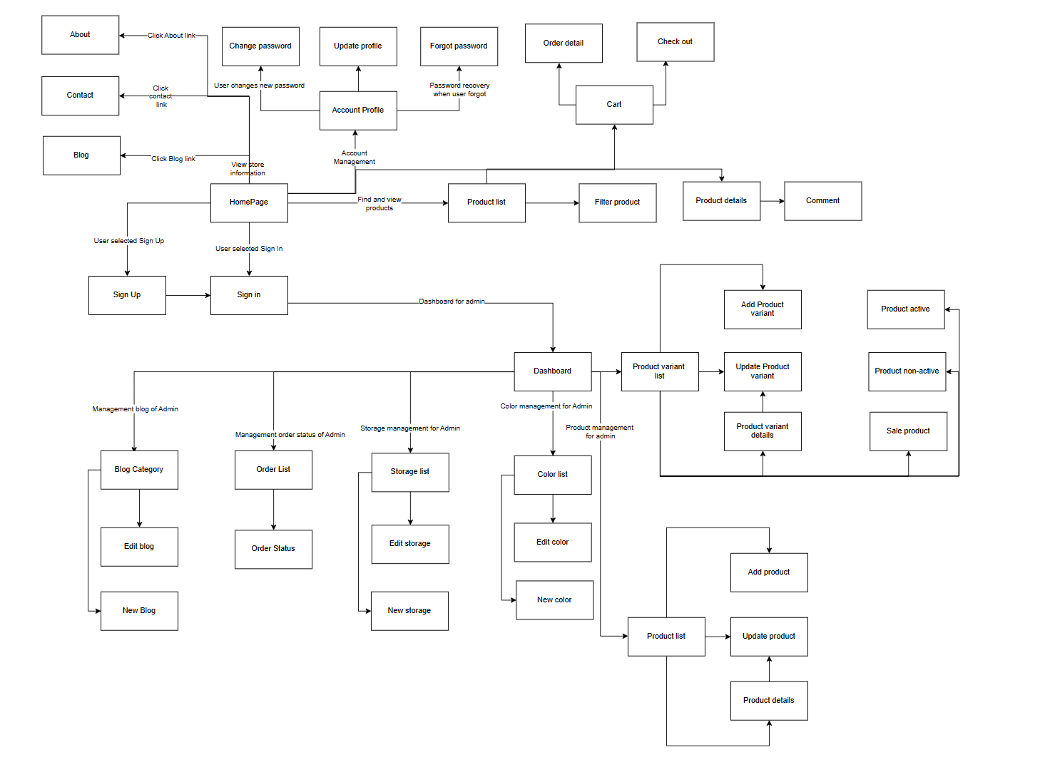

### 6.2 Screen details

| **#** | **Feature** | **Screen** | **Description** |
| --- | --- | --- | --- |
| 1 | Homepage | Homepage | Header: Navbar include Logo, Home, About, Store, Contact, Cart, Sign in/Sign up  Banner about shop accompanied by a shopping button  Content:Information about some featured products  Footer: Contact information and shop logo |
| 2 | Sign in | Sign in | Header: Logo shop  Main Content: Sign in form: Username, Password,Button sign in. Link to Forgot Password, Link to Sign up  Footer: Contact information about shop |
| 3 | Forgot Password | Forgot Password | Header: Navbar include Logo, Home, About, Store, Contact, Cart, Sign in/Sign up  Main Content: Forgot Password form: UserName, choose and answer Security Question, Password, re_password, submit button  Footer: Contact information and shop logo |
| 4 | Sign Up | Sign Up | Header: Navbar include Logo, Home, About, Store, Contact, Cart, Sign in/Sign up  Main Content: Sign Up form: Username, Password, Re_password, Name, choose and answer Security Question, Phone, Sign Up button  Footer: Contact information and shop logo |
| 5 | Product Page | Product Page | Header: Navbar include Logo, Home, About, Store, Contact, Cart, Sign in/Sign up  Main Content: Filter Product( Filter by price,Filter by color, Filter by storage, Sort product). Show all products. Paging  Footer: Contact information and shop logo |
| 6 | Product Detail Page | Product Detail Page | Header: Navbar include Logo, Home, About, Store, Contact, Cart, Sign in/Sign up  Main Content:   * Image of Product * Choose option: Product color, Product Storage * Total price and add to cart button * Description and Review about product * Information about some featured products   Footer: Contact information and shop logo |
| 7 | Account Profile | Account Profile | Header: Navbar include Logo, Home, About, Store, Contact, Cart, Notification, UserName  Main Content: Update Profile form: Full name, choose Gender, Update phone, Update address, Update button  Footer: Contact information and shop logo |
| 8 | Change Password | Change Password | Header: Navbar include Logo, Home, About, Store, Contact, Cart, Notification, UserName  Main Content: Change Password form: Current password, New password, Verify new password, Update button  Footer: Contact information and shop logo |
| 9 | Filter production | Product Page | Header: Navbar include Logo, Home, About, Store, Contact, Cart, Notification, UserName  Main Content: FILTER BY PRICE $,FILTER BY STORAGE,Sort by,filter by color  Footer: Contact information and shop logo |
| 10 | Search product | Product Page | Header: Navbar include Logo, Home, About, Store, Contact, Cart, Notification, UserName  Main Content: Search product  Footer: Contact information and shop logo |
| 11 | Dashboard | Dashboard | Header: Navbar include Logo, Home, About, Store, Contact, Cart, Notification, UserName  Main Content: Dashboard  Footer: Contact information and shop logo |
| 12 | Product Dashboard | Product Dashboard | Header: Navbar include Logo, Home, About, Store, Contact, Cart, Notification, UserName  Main Content: Product Dashboard  Footer: Contact information and shop logo |
| 12 | Add product | Product Dashboard | Header: Search, UserName  Main Content:Name,Price,Screen,ScreenResolution,  Camera,Ram,Pin,Chipset,Description,Image,add  Footer: Contact information and shop logo |
| 13 | Update product | Product Dashboard | Header: Search, UserName  Main Content:Name,Price,Screen,ScreenResolution,  Camera,Ram,Pin,Chipset,Description,Image,add  Footer: Contact information and shop logo |
| 14 | Hide Product | Hide Product | Header: Search, UserName  Main Content: Hide Name, Price, Screen, Screen Resolution, Camera ,Ram , Pin, Chipset, Description, Image.  Footer: Contact information and shop logo |
| 15 | Product Variant Dashboard | Product Variant Dashboard | Header: Navbar include Logo, Home, About, Store, Contact, Cart, Notification, UserName  Main Content: Product Variant Dashboard  Footer: Contact information and shop logo |
| 16 | Add Product Variant | Add Product Variant | Header: Search, UserName  Main Content: Add Name, Price, Screen, Screen Resolution, Camera ,Ram , Pin, Chipset, Description, Image.  Footer: Contact information and shop logo |
| 17 | Update Product Variant | Update Product Variant | Header: Search, UserName  Main Content: Update Name, Price, Screen, Screen Resolution, Camera ,Ram , Pin, Chipset, Description, Image.  Footer: Contact information and shop logo |
| 18 | Hide Product Variant | Hide Product Variant | Header: Search, UserName  Main Content: Hide Name, Price, Screen, Screen Resolution, Camera ,Ram , Pin, Chipset, Description, Image.  Footer: Contact information and shop logo |
| 19 | Update profile | Account Profile | Header: Navbar include Logo, Home, About, Store, Contact, Cart, Notification, UserName  Main Content: Fullname , Gender, Phone , Address.  Footer: Contact information and shop logo |
| 20 | Account profile | Account profile | Header: Navbar include Logo, Home, About, Store, Contact, Cart, Notification, UserName  Main Content: Fullname , Gender, Phone , Address.  Footer: Contact information and shop logo |
| 21 | Color Management | Color Management | Header: Navbar include Logo, Home, About, Store, Contact, Cart, Notification, UserName  Main Content: Tools for calibrating displays, managing ICC profiles, selecting color spaces and rendering intents, printer color management, soft proofing, color correction, swatches, profile conversion, and gamut warning. Ensures consistent and accurate colors across devices and applications  Footer: Contact information and shop logo |
| 22 | Storage Management | Storage Management | Header: Navbar include Logo, Home, About, Store, Contact, Cart, Notification, UserName  Main Content: Product Inventory: Manage product details and categories. Product Media: Upload and optimize images/videos. Stock Management: Track and update product quantities. Order Management: Organize and update customer orders.  Footer: Contact information and shop logo |
| 23 | Order History | Order History | Header: Navbar include Logo, Home, About, Store, Contact, Cart, Notification, UserName  MainContent: Order Number,Order Date, Order Status, Order Total, Payment Information, Shipping Address, Invoices, Actions  Footer: Contact information and shop logo |
| 24 | List Order | List Order | Header: Navbar include Logo, Home, About, Store, Contact, Cart, Notification, UserName  MainContent:  Order Details: Order ID, date, and customer information. Product Information: List of ordered items with details. Order Status: Current status and tracking information. Order History: View past orders and reorder options. Order Updates: Notifications for status changes.  Footer: Contact information and shop logo |
| 25 | Search Order | Search Order | Header: Navbar include Logo, Home, About, Store, Contact, Cart, Notification, UserName  MainContent:  Search Filters: Order ID, customer name, date range, and status. Search Results: Display relevant orders with details. Order Details: View order information, products, and total amount. Order Status: Check current status and tracking (if applicable). Order History: Access to customer's past orders. Order Modification: Edit or modify orders (if allowed).  Footer: Contact information and shop logo |
| 26 | Filter order | Filter order | Header: Navbar include Logo, Home, About, Store, Contact, Cart, Notification, UserName  MainContent:  Filter Options: Order ID, Date Range, Customer Name, Order Status. Apply Filters: Button to activate selected filters. Reset Filters: Option to clear applied filters. Filtered Order Results: Display of matching orders. Sort Order Results: Sorting by date, customer name, or status. View Order Details: Clickable order ID for more information. Pagination (Optional): Navigation for multiple results. Clear Filter Button: Conveniently reset all filters.  Footer: Contact information and shop logo |
| 27 | Order management | Order management | Header: Navbar include Logo, Home, About, Store, Contact, Cart, Notification, UserName  Main Content: Order List,Order Details,Order Status Updates, Order Fulfillment, Inventory Management, Customer Communication, Returns and Refunds  Footer: Contact information and shop logo |
| 28 | Shopping Cart | Shopping Cart | Header: Navbar include Logo, Home, About, Store, Contact, Cart, Notification, UserName  Main Content: Product Information, Subtotal, Promotions and Discounts, Total Cost, Shipping Information, Payment Options, Quantity and Remove Options, Proceed to Checkout, Related Products, Order Summary.  Footer: Contact information and shop logo |
| 29 | Add to cart | Add to cart | Header: Navbar include Logo, Home, About, Store, Contact, Cart, Notification, UserName  Main Content: Product Information, Quantity Selection, Price and Total, Product Options, Availability and Stock Information, Add to Cart Button, Cart Summary or Mini Cart, Related or Recommended Products  Footer: Contact information and shop logo |
| 30 | Check out | Check out | Header: Navbar include Logo, Home, About, Store, Contact, Cart, Notification, UserName  Main Content:  Order Summary, Shipping Information , Billing Information, Payment Method Selection, Promo Codes or Coupons, Terms and Conditions, Confirmation and Order Completion.  Footer: Contact information and shop logo |
| 31 | Contact | Contact | Header: Navbar include Logo, Home, About, Store, Contact, Cart, Notification, UserName  Main Content:  Contact Information: Business name, address, phone, email.  Contact Form: User-friendly form for inquiries.  Business Hours: Operating hours for support.  Social Media Links: Links to social media profiles.  Map and Directions (if applicable).  Customer Support: Support contact details.  Footer: Contact information and shop logo |
| 32 | About Us | About Us | Header: Navbar include Logo, Home, About, Store, Contact, Cart, Notification, UserName  Main Content:  Our Story: Briefly describe the company's history and mission.  Vision and Values: Highlight the company's core values and long-term goals.  Team: Introduce key members or founders of the team.  Commitment: Emphasize the commitment to customer satisfaction.  Unique Selling Points: Highlight what sets the company apart from competitors.  Testimonials (optional): Include positive feedback from satisfied customers.  Contact Information: Provide ways to get in touch for more information.  Footer: Contact information and shop logo |
| 33 | Sale Management | Sale Management | Header: Navbar include Logo, Home, About, Store, Contact, Cart, Notification, UserName  Main Content:  Sales Dashboard: Overview of sales performance and key metrics.  Sales Team: Introduction to the sales team and their roles.  Sales Pipeline: Visualization of the sales process stages.  Sales Targets: Setting and monitoring sales goals.  Sales Reports: Detailed analysis of sales data and trends.  Footer: Contact information and shop logo |
| 34 | Order Status | Order Status | Header: Navbar include Logo, Home, About, Store, Contact, Cart, Notification, UserName  Main Content:  Order Status Overview: Summary of the order status and progress.  Order Details: Display of order ID, date, and customer information.  Shipment Tracking: Tracking information for shipped orders.  Current Status: Clear indication of the current order status  Estimated Delivery: Expected delivery date or time frame.  Order Updates: Notifications for status changes  Order History: Access to past order statuses and details.  Footer: Contact information and shop logo |
| 35 | Comment | Comment | Header: Navbar include Logo, Home, About, Store, Contact, Cart, Notification, UserName  Main Content:  Comment Section: A designated area for users to leave comments.  User Name: Displaying the name or username of the comment author.  Date and Time: Timestamp of when the comment was posted.  Comment Content: The actual comment or message left by the user.  Reply (optional): Ability to reply to a specific comment.  Moderation (optional): Comment moderation to filter inappropriate content.  Report (optional): A feature to report abusive or spam comments.  Avatar/Profile Picture (optional): Displaying the user's avatar or profile picture.  Sort (optional): Sorting options for comments (e.g., newest, oldest, most liked).  Footer: Contact information and shop logo |
| 36 | Manage Blog Category | Manage Blog Category | Header: Navbar include Logo, Home, About, Store, Contact, Cart, Notification, UserName  Main Content:  Category Overview: Display of existing blog categories.  Create New Category: Option to add a new category.  Edit Category: Ability to modify category names or details.  Delete Category: Option to remove unnecessary categories.  Assign Posts: Assigning blog posts to relevant categories.  Category Organization: Drag-and-drop to reorder categories (if applicable).  Category Details: Information on each category, such as ID and creation date.  Footer: Contact information and shop logo |
| 37 | Manage Blog | Manage Blog | Header: Navbar include Logo, Home, About, Store, Contact, Cart, Notification, UserName  Main Content:  Blog Overview: Display of existing blog posts.  Create New Post: Option to add a new blog post.  Edit Post: Ability to modify blog post content.  Delete Post: Option to remove unwanted blog posts.  Categories: Assigning posts to relevant blog categories.  Tags (optional): Adding tags for post organization and search.  Publish Date: Setting the date and time for post publication.  Featured Image (optional): Uploading images to represent the post.  Post Preview: Previewing the post before publishing.  Save/Update: Button to save changes and update blog posts.  Footer: Contact information and shop logo |
| 38 | Blog Dashboard | Blog Dashboard | Header: Navbar include Logo, Home, About, Store, Contact, Cart, Notification, UserName  Main Content:  Blog Overview: Summary of blog performance and statistics.  Recent Posts: Display of the most recent blog posts.  Drafts: List of blog posts in draft status.  Published Posts: List of published blog posts.  Comments: Overview of comments received on blog posts.  Categories: Display of existing blog categories.  Tags (optional): List of tags used in blog posts.  Popular Posts (optional): Highlighting posts with the most views or engagement.  Blog Analytics (optional): Metrics on blog traffic, views, and user engagement.  Create New Post: Option to start writing a new blog post.  Footer: Contact information and shop logo |

### 6.3 User Authorization

| **Screen** | **Guest** | **User** | **Admin** |
| --- | --- | --- | --- |
| Homepage | X | X | X |
| Sign in |  | X | X |
| Sign up | X |  |  |
| Product page | X | X | X |
| Product Detail page | X | X | X |
| Forgot Password |  | X | X |
| Change password |  | X | X |
| Filter production | X | X | X |
| Search product | X | X | X |
| Dashboard |  |  | x |
| Product Dashboard |  |  | x |
| Add product |  |  | X |
| Update product |  |  | X |
| Hide product |  |  | X |
| Product Variant Dashboard |  |  | x |
| Add Product Variant |  |  | x |
| Update Product Variant |  |  | x |
| Hide Product Variant |  |  | x |
| Update profile |  | X | X |
| Account Profile |  | X | X |
| Color Management |  |  | x |
| Storage Management |  |  | x |
| Order History | x |  | x |
| List Order | x |  | x |
| Search order | x | x | x |
| Filter order | x |  | x |
| Order Management |  |  | x |
| Shopping cart | x |  |  |
| Add to cart |  |  | x |
| Checkout | x |  |  |
| Contact | x | x | x |
| About us | x | x | x |
| Sale Management |  |  | x |
| Order Status |  |  | x |
| Comment | x |  |  |
| Manage Blog Category |  |  | x |
| Manage Blog |  |  | x |
| Blog Dashboard |  |  | x |

### 

## 7. Entity relationship diagram

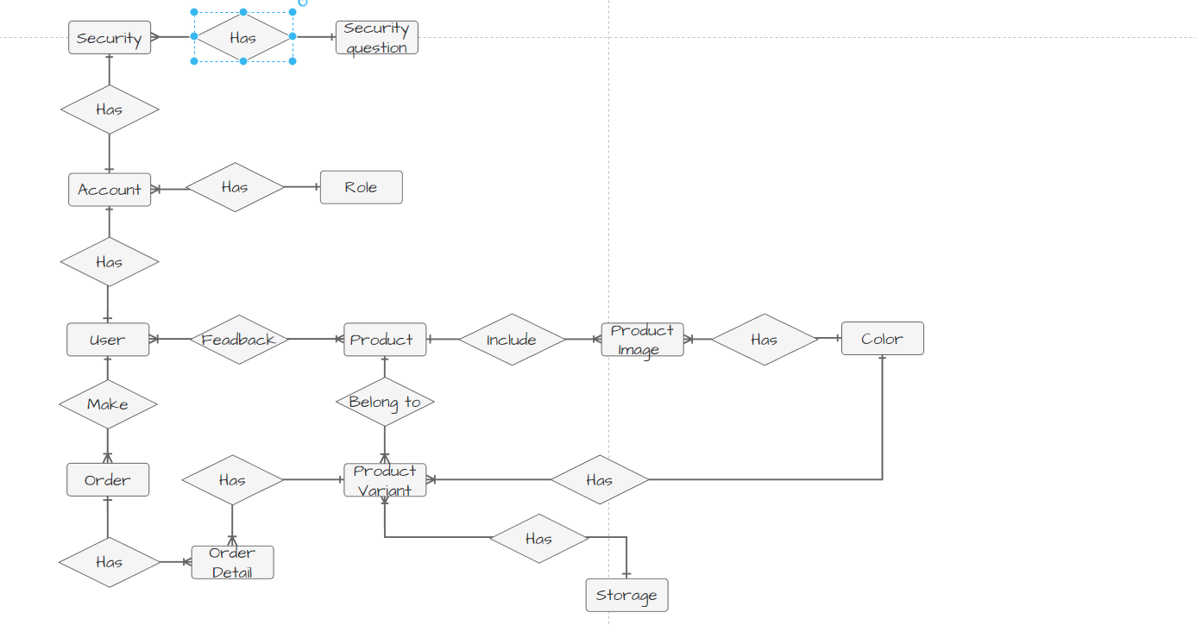

## 8. General Constraints

### Naming convention:

* Camel case variables: Variables must be named using uppercase letters, where words are combined without spaces and begin with a capital letter for the first letter of each word. For example: product list, product details… For example: ProductList, ProductDetail…

### Architectural Constraints:

* MVC Model (Model-View-Controller): following the MVC architectural pattern, This model divides the application structure into three main parts, each with separate responsibilities to help increase security, reuse and control testing during software development.

### Web Standards Constraint:

* HTML and CSS Standards: The HTML and CSS code should be designed and coded following web standards. This includes adhering to the specific coding practices, guidelines, and best practices defined by web standards organizations such as the World Wide Web Consortium (W3C) for HTML and CSS.

These constraints ensure consistency, maintainability, and adherence to industry best practices and standards throughout the development process of the Durian Store. They promote code readability, documentation, and a robust architecture that follows established patterns and conventions.

# **III. Specific Requirements**

## 1. Requires external interface

### 1.1 User Interface

UI-1: Page Layout and Site Header

* The site title should include:
* Logo: Displays the website's logo.
* Menu: Display nav-bar, home, about, shop, contact, cart, use, sign-in, sign-up.
* Body: Display all images of the product and about the Durian shop.
* The middle of the page will show the products the iPhone models will be compatible with.
* Footer: The bottom of the page should be divided into shop copyright information, logo, menu.

UI-2: Responsive Design

* The interface should be designed to be suitable for display on both computers and mobile phones.
* The website should be responsive, adjusting its layout and content based on the device's screen size and orientation.

### 1.2 Hardware Interface

* Based on the information provided, Durian Store has external interface requirements regarding iPhone generations. Here are the iPhone generations interface requirements:
* Iphone generations interface:

Durian Store must be compatible with standard iPhone generations, including: Iphone SE to Iphone 14 ProMax.

* All Iphones of each year: all of color, storage,...

Display: The interface must display correctly on each screen. Such as: when the user chooses a color, the screen ProductDetail must display images of that color. The easy-to-see interface is suitable for most users, giving everyone a detailed view of each product.

### 1.3 Software interface

Web browser interface: Durian Store is accessible through standard web browsers, such as Google Chrome and Microsoft Edge.

Websites must be compatible with the latest versions of these web browsers to ensure proper functionality and optimal user experience.The interface should be adapting the layout and content of websites. To be able to provide the best user experience.

## 2. Use Cases

### 2.1 Use Case Overview

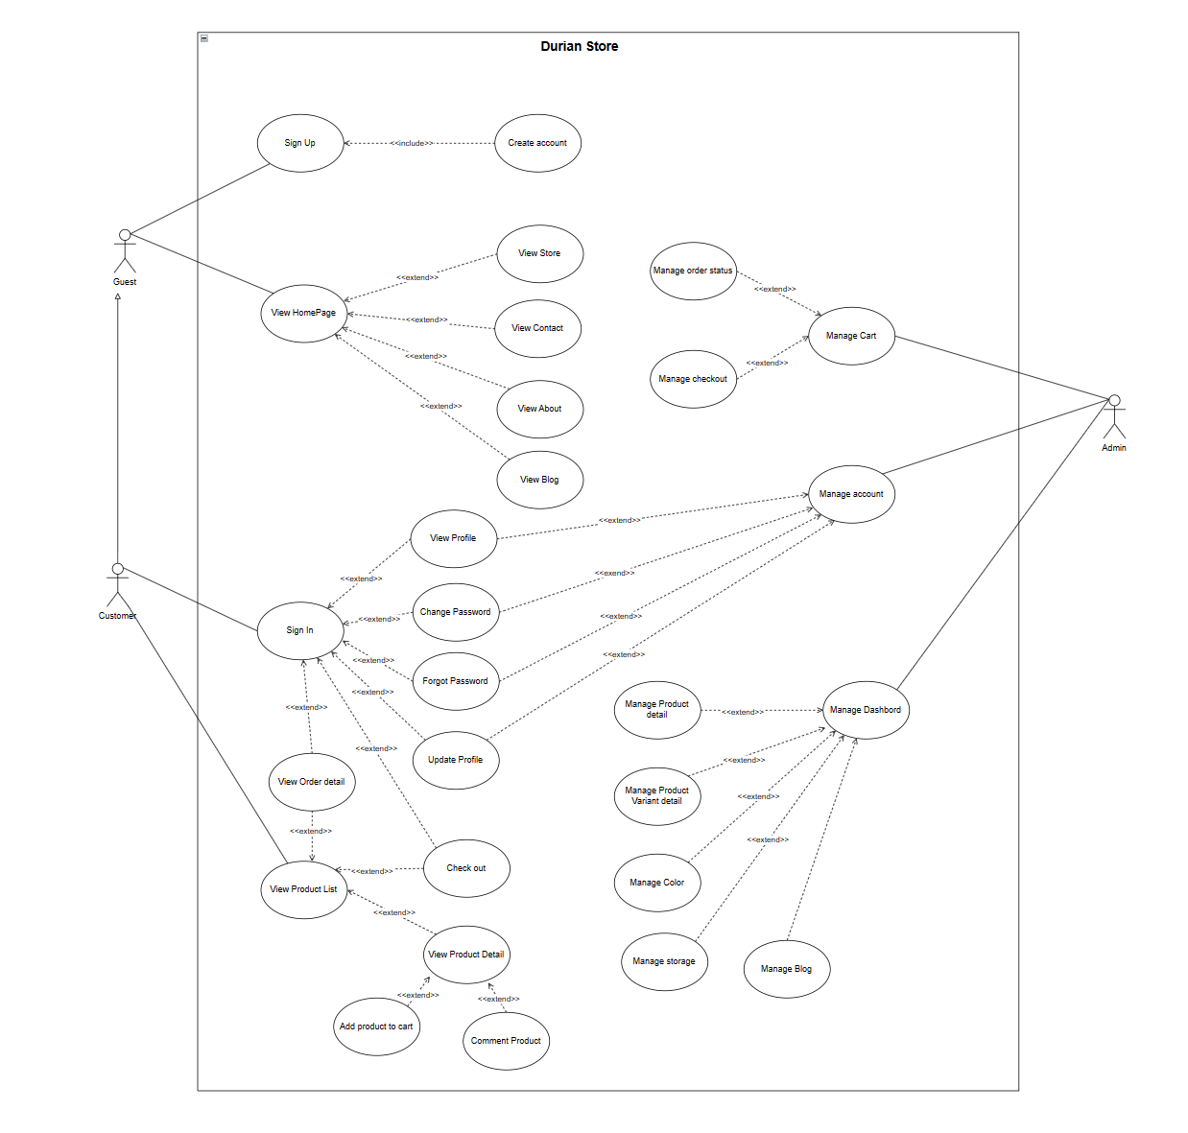

### 2.2 Use Case Guest

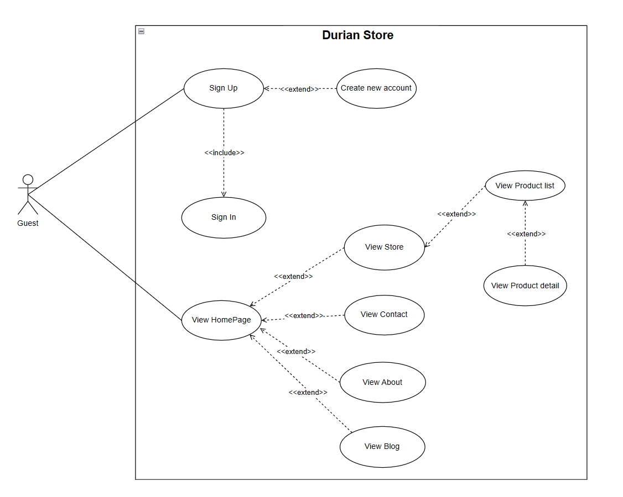

* Use Case: Guest - Durian Shop.
* Introduction:
* The guest can use the functions available to non-account users such as: view home page, view product page, view product detail page, search product, view comments about product or sign up a new account.
* Actors:
* Guest: Is a non-account user.
* Use Cases:

- View Homepage: Guests can view all general information about The Durian Shop.

- View Product list: When choose Store, guests can see all products of the Store.

- View Product detail: When clicking a product. Guests can see all information about this product.

- Sign up: Enter username, password and some personal information to sign up the website.

- Sign in: Guests can enter Username and Password but can't login because Guests don't have an account.

- View Contact: Guests can see the address, contact information of the store.

- View Comment: Guests can see comments about the products they are viewing.

### 2.3 Use Case Customer

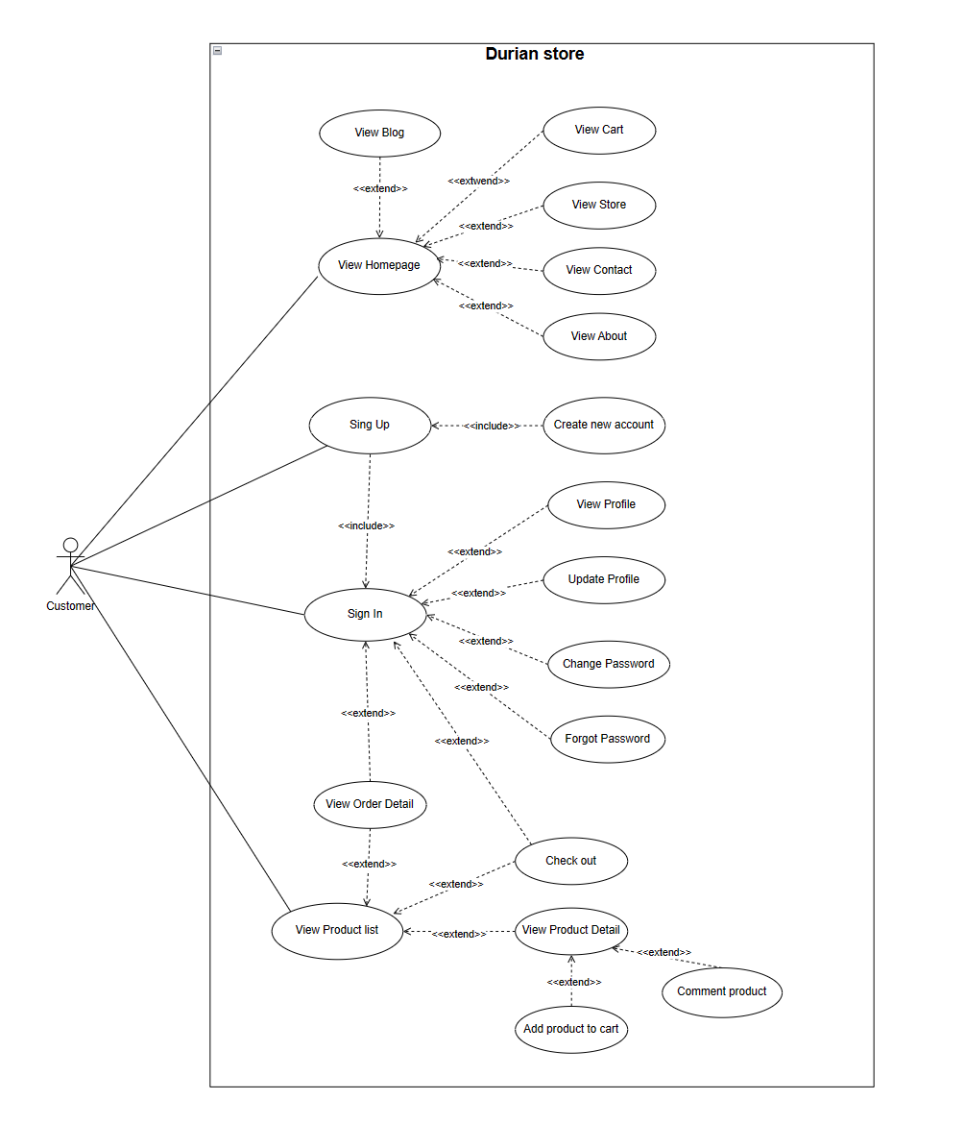

* Use Case: Customer - Durian Store.
* Introduction:
* The Customer use case in the Durian Store system refers to the activities and functionalities available to registered customers who have created an account on the online shop. Customers can perform various actions such as browsing products, managing their account details, and choosing the items.
* Actors:
* Customer: A registered user who has created an account on the Durian Store.
* Use Cases:

Customer inherits all the functions that Guest can do, in addition, Customer has its own functions that Guest does not have.

After Customer logs into the system, they can perform functions such as:

+ View profile: allows users to view their personal information stored in the user profile. Help users double check personal information and confirm that it is properly stored and displayed.

+ Update profile: allows users to edit and update their personal information in the user profile.

+ Change Password: allows users to change their current password to a new password. Ensure the security of user accounts.

+ Forgot Password: allows users to recover their password in case they forget their current password.

+ View order detail: allows users to view detailed information about a specific order they have placed.

+ Add to cart: allows the user to add the desired product to the cart before proceeding with the payment.

+ Check out: allows users to proceed to pay for the products in the cart, complete the payment process and place an official order.

+ View Cart: allows users to view information about the products currently in their cart. Help users to check the products added to the cart, then adjust the quantity or delete unnecessary products in the cart.

### 2.4 Use Case Admin

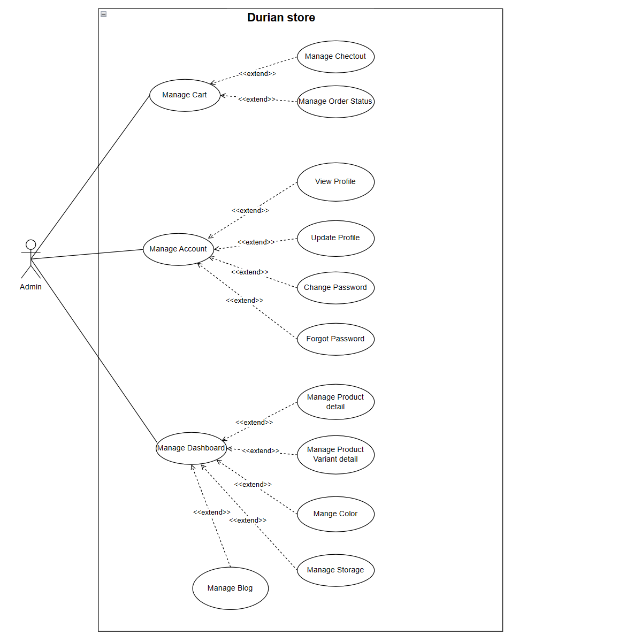

* Use Case: Admin - Durian Store.
* Introduction:
* Admin has an important role in operating the management system of the store's functions, product system and user accounts.
* Actors:
* Admin: As the store's system manager.
* Use Cases:

Admin UCs:

- Sign In: Log in with a special username and password reserved for admin.

- Manage cart: allows admin to manage user's cart.

+ Manage order status: manage the details of the order, help the admin manage and control the details related to the orders in the system.

+ Manage Check out: manage the payment process in the system, help admin control and track the payment process of orders.

- Manage Account: allows admin to manage user accounts in the system.

View profile: allows admin to view personal information of a specific user.

- Manage Dashboard: allows admin to manage the dashboard of the system.

+ Manage Product detail: allows admin to manage detailed information about products in the system, including adding new products, viewing product details or editing product details if needed.

+ Manage Product Variant detail: allows admin to manage information about product variations, including adding new products, viewing product details or editing product details if needed.

+ Manage Color: allows admin to manage the list of colors in the system.

+ Manage Storage: allows admin to manage the storage list in the system.

## 3. Functional Requirements

### 

### 3.1 View HomePage

| UC ID and Name: | HomePage | | |
| --- | --- | --- | --- |
| Created By: | HoaPT | Date Created: | 28/05/2023 |
| Primary Actor: | Admin | Other Actors: | User, Viewer |
| Trigger: | Actor clicks Logo | | |
| Description: | Actors can watch all that production | | |
| Normal Flow: | 1. Actor selects and clicks on the "Home" link. | | |
| Frequency of Use: | Usually | | |
| Preconditions: | N/A | | |
| Postconditions: | N/A | | |

### 

### 3.2 Sign in account

| UC ID and Name: | Sign in | | |
| --- | --- | --- | --- |
| Created By: | Cao Quan | Date Created: | 26/05/2023 |
| Primary Actor: | Admin | Secondary Actors: | Customer |
| Trigger: | Click on the login button in the head of the website interface | | |
| Description: | People log into the system to use the system's functions | | |
| Preconditions: | 1. Customer must already have an account to sign in  2. must enter the correct username and password | | |
| Postconditions: | 1. Customer successfully sign in and access the home page | | |
| Normal Flow: | 1. Type url of website on Internet browser and enter  2. Software: Display Login screen with the following fields: User name, Password, Login button  3. People enter username and password then click login button  4. Software: Validate username and password | | |
| Exceptions: | 1. Error message: Required fields need to be entered if the customer is missing  2. Error message: Invalid username and/or password if the username and password are not found in sql | | |
| Priority: | Normal | | |
| Frequency of Use: | Usually | | |

### 

### 

### 3.3 Sign-up

| UC ID and Name: | Guest User Sign-up | | |
| --- | --- | --- | --- |
| Created By: | TungVS | Date Created: | 28/05/2023 |
| Primary Actor: | Guest User | Other Actors: | N/A |
| Trigger: | User clicks “SignUP” on home screen | | |
| Description: | User can create a new account after filled the form | | |
| Preconditions: | The customer do not sign-in the page | | |
| Postconditions: | Send redirect to Login Page | | |
| Normal Flow: | 1. Actor select Register button  2. System: Display Register Page screen  3. User fill all required information after click on “Register” button  4. System check validate , duplicate information of user  5. System displays the message “Registration successful” and navigates to the login page. | | |
| Alternative Flows: | N/A | | |
| Exceptions: | 1. Users don’t fill in all required information or user username that already exists. After click on “SignUp” button  2. System check validate, duplicate information of user  3. System display message of that error and back to the SignUp page. | | |
| Frequency of Use: | Usually | | |

### 3.4 Product Page

| UC ID and Name: | Product Page | | |
| --- | --- | --- | --- |
| Created By: | TuDA | Date Created: | 25/05/2023 |
| Primary Actor: | Admin | Other Actors: | User, Viewer |
| Trigger: | Actor clicks on button to buy product. | | |
| Description: | The Product List Page is a web page that provides description information about a product. It allows the customer to know about product. | | |
| Preconditions: | Redirect users from the homepage to the product list page. | | |
| Postconditions: | System show information about the product that actor want view : name , price , parameter , status, image. | | |
| Normal Flow: | 1.Actor clicks on the Product List  2.The system displays a list of products with information such as “name , price , status , image, parameter”.  3.Actor process Click ”Buy Now” button  4.The system will send a request to the user to come Product Details, in here user can see details of any product if user want to buy. | | |
| Priority: | Normal | | |
| Frequency of Use: | Usually | | |

### 

### 

### 

### 

### 

### 

### 3.5 Product Details

| UC ID and Name: | Product Details | | |
| --- | --- | --- | --- |
| Created By: | Kieu Kien | Date Create | 21/05/2023 |
| Primary Actor: | User | Other Actors | Guest, Admin |
| Trigger: | The customer selects a product from a list or search results and clicks on it to view more details. | | |
| Description: | The Product Detail Page is a web page that provides comprehensive information about a specific product. It allows the customer to gather detailed information, make informed decisions. | | |
| Preconditions: | 1. The customer has access to the website. 2. The customer has performed a search or navigated to a list of products. 3. A product has been selected for viewing | | |
| Postconditions: | 1. The customer has obtained detailed information about the product. 2. The customer may proceed with purchasing the product or return to the previous page. | | |
| Exceptions: | N/A | | |

### 3.6 Forgot password

| UC ID and Name: | Forgot Password | | |
| --- | --- | --- | --- |
| Created By: | SonNC | Date Created: | 27/05/2023 |
| Primary Actor: | User | Other Actors: | Admin |
| Trigger: | Actor clicks on “Forgot Password” section. | | |
| Description: | Actor can Recover the forgot password. | | |
| Preconditions: | Actor must answer the security question that the actor posed at sign up. | | |
| Postconditions: | Actor create new password.2 | | |
| Normal Flow: | 1. Actor chooses Forgot password.  2. System force Actor answer the security question.  3. Actor can create a new password. | | |
| Priority: | Normal | | |
| Frequency of Use: | Usually | | |

### 

### 3.7 Change Password

| ID and Name | UC: Change Password | | |
| --- | --- | --- | --- |
| Created By: | Nguyen Son | Date Created: | 17/06/2023 |
| Primary Actor: | User | Secondary Actors |  |
| Description: | The user has an account on the system and wants to change the password. | | |
| Trigger: | Click the option "Change password". | | |
| Preconditions: | PRE-1. The user has an account on the system.  PRE-2. User has access to his account on the system. | | |
| Postconditions: | POST-1. Password was successfully changed. | | |
| Normal Flow: | 1. User accesses the account and selects the option “Change password”.  2. The system displays the password change interface, asking the user to enter a new password.  3. The user enters a new password in the respective fields.  4. The system checks the validity of the new password.  5. If the new password is valid, the system will save the new password to the user account.  6. The system displays a successful message and confirms that the password has been changed. | | |
| Alternative Flows: | In step 4, if the current password does not match or the new password is invalid, the system displays an error message and asks the user to re-enter it. | | |
| Exceptions: | N/A | | |
| Priority: | Normal | | |
| Frequency of Use: | Medium | | |
| Business Rules: | BR-01, BR-02 | | |
| Other Information: | N/A | | |
| Assumptions: | N/A | | |

### 

### 

### 3.8 Filter Product

| ID and Name | UC: Filter Product | | |
| --- | --- | --- | --- |
| Created By: | Kien Kieu | Date Created: | 17/06/2023 |
| Primary Actor: | User | Secondary Actors |  |
| Description: | Allows users to customize search results to suit their needs and preferences. | | |
| Trigger: | Clicks on options which user want to filter. | | |
| Preconditions: | PRE-1. Click on options.  PRE-2. List of products that have been loaded or displayed. | | |
| Postconditions: | POST-1. Non-conforming products have been removed or hidden, showing only products that match the selected criteria. | | |
| Normal Flow: | 1. User accesses Filter Product function.  2. The list of original products is displayed.  3. User selects filters according to need (e.g. price, color, date, etc.).  4. The system applies the selected filters and displays a new product list according to the applied criteria.  5. The user views the filtered product list. | | |
| Alternative Flows: | N/A | | |
| Exceptions: | N/A | | |
| Priority: | Normal | | |
| Frequency of Use: | Usually | | |
| Business Rules: | N/A | | |
| Other Information: | N/A | | |
| Assumptions: | N/A | | |

### 

### 

### 3.9 Search Product

| ID and Name | UC: Search Product | | |
| --- | --- | --- | --- |
| Created By: | Kien Kieu | Date Created: | 17/06/2023 |
| Primary Actor: | Admin, User | Secondary Actors |  |
| Description: | Search for specific products on the site | | |
| Trigger: | Clicks “Search Products” input on the screen | | |
| Preconditions: | PRE-1. Visited the website.  PRE-2. Users click and typed some thing that need to search. | | |
| Postconditions: | POST-1. A list of products that match the search query is displayed to the user. | | |
| Normal Flow: | 1. The user enters the product keyword in the search box.  2. The system processes and searches the database based on the entered information.  3. The system displays search results including a list of products matching the search requirements.  4. The user views the list of found products. | | |
| Alternative Flows: | In step 2, if there are no products matching the search request, the system displays a message to the user. | | |
| Exceptions: | N/A | | |
| Priority: | Normal | | |
| Frequency of Use: | Usually | | |
| Business Rules: | N/A | | |
| Other Information: | N/A | | |
| Assumptions: | N/A | | |

### 

### 

### 3.10 DashBoard

| ID and Name | UC: DashBoard | | |
| --- | --- | --- | --- |
| Created By: | Son Tung | Date Created: | 17/06/2023 |
| Primary Actor: | Admin | Secondary Actors |  |
| Description: | A dashboard is a visual representation of data that provides an overview of key information and metrics in a consolidated and easily understandable format | | |
| Trigger: | To trigger a dashboard, you would typically need a data source from which you want to collect information and display it on the dashboard | | |
| Preconditions: | PRE-1. Visited the website.  PRE-2. Determine the primary purpose of the dashboard, whether it's for monitoring real-time data, historical trend analysis, or making strategic decisions. | | |
| Postconditions: | POST-1. After creating and implementing a dashboard, there are several postconditions or outcomes that you can expect to observe | | |
| Normal Flow: | 1. The process begins with clearly defining the purpose of the dashboard and understanding the specific requirements of its users.  2. Once the requirements are established, the relevant data sources are identified, and mechanisms are set up to collect and integrate data from these sources.  3. Before deploying the dashboard, conduct thorough testing to ensure that all visualizations work correctly, data is accurate, and interactive features function as intended.  4. Once the dashboard is tested and approved, deploy it to the intended users or the organization. This could involve hosting the dashboard on a web server or sharing it through other means, depending on the dashboard platform used. | | |
| Alternative Flows: | In the process of creating and maintaining a dashboard, various alternative flows or scenarios may arise depending on specific circumstances, challenges, or changes in requirements. | | |
| Exceptions: | N/A | | |
| Priority: | Normal | | |
| Frequency of Use: | Medium | | |
| Business Rules: | BR-02 | | |
| Other Information: | N/A | | |
| Assumptions: | N/A | | |

### 

### 

### 3.11 Product DashBoard

| ID and Name | UC: Product DashBoard | | |
| --- | --- | --- | --- |
| Created By: | Cao Quan | Date Created: | 19/06/2023 |
| Primary Actor: | Admin | Secondary Actors | Product Managers |
| Description: | The "Product Dashboard - Display Products" use case allows the website administrator to view and manage the display of products on the website's product dashboard. The product dashboard is an administrative section that provides an overview of all the products available for sale or display on the website. | | |
| Trigger: | When product managers and the sales team need to access real-time product data and performance metrics to make data-driven decisions. | | |
| Preconditions: | PRE-1. The admin and other users have visited the website or dashboard platform.  PRE-2. The primary purpose of the Product Dashboard is determined, focusing on monitoring real-time product data, historical trend analysis, and making strategic decisions. | | |
| Postconditions: | POST-1. After creating and implementing the Product Dashboard, product managers and the sales team have access to valuable insights and key metrics for product performance. | | |
| Normal Flow: | 1.The website administrator logs into the administrative interface of the website.  2.The administrator navigates to the "Product Dashboard" section.  3.The system presents an overview of all available products in a tabular format.  4.For each product, the following details are displayed | | |
| Alternative Flows: | Data Source Unavailability: If a data source becomes unavailable or experiences technical issues, the Product Dashboard may display outdated or incomplete information.. | | |
| Exceptions: | N/A | | |
| Priority: | Normal | | |
| Frequency of Use: | Medium | | |
| Business Rules: | BR-02 | | |
| Other Information: | N/A | | |
| Assumptions: | N/A | | |

### 

### 

### 

### 3.12 Add product

| ID and Name | UC: Add Product | | |
| --- | --- | --- | --- |
| Created By: | Do Tu | Date Created: | 17/06/2023 |
| Primary Actor: | Admin | Secondary Actors |  |
| Description: | Allows admin to add a new product to the system. | | |
| Trigger: | Click the option “Add Product” | | |
| Preconditions: | PRE-1. Log in to the system | | |
| Postconditions: | POST-1. The product has been successfully added and stored in the product list.  POST-2. New products are displayed in the product list. | | |
| Normal Flow: | 1. User accesses the "Add Product" function.  2. The system displays a blank product details form for users to fill in.  3. User provides detailed product information, such as name, price, image, ram, etc.  4. User presses "Add product" button to save product information.  5. The system checks the validity and correctness of product information.  6.The system stores new products in the product list and displays the product list. | | |
| Alternative Flows: | In step 5, the user does not provide enough required information, the system displays an error message asking the user to provide all required information before adding the product. | | |
| Exceptions: | N/A | | |
| Priority: | Normal | | |
| Frequency of Use: | Medium | | |
| Business Rules: | BR-03, BR-04, BR-06 | | |
| Other Information: | N/A | | |
| Assumptions: | N/A | | |

### 

### 

### 

### 3.13 Update product

| ID and Name | UC: Update product | | |
| --- | --- | --- | --- |
| Created By: | Do Tu | Date Created: | 17/06/2023 |
| Primary Actor: | Admin | Secondary Actors |  |
| Description: | Allows the management system to edit and update product descriptions. | | |
| Trigger: | Click the option “Update Product” | | |
| Preconditions: | PRE-1. The product already exists in the system with an initial description. | | |
| Postconditions: | POST-1. Product description updated successfully.  POST-2. The customer can see the edited description. | | |
| Normal Flow: | 1. Admin accesses the product management system .  2. Admin selects the product to update the description.  3. Retrieval and display system for editing admin.  4. Admin makes the necessary changes to the description.  5. Admin saves the updated description.  6. Updated description validation system to ensure compliance with constraints.  7. The system updates the product description in the database and reflects the changes on the website.  8. Customers browsing the product on the website now see the updated description. | | |
| Alternative Flows: | In step 6, if the authentication fails, the system displays an error message and asks the admin to make the necessary modifications. | | |
| Exceptions: | N/A | | |
| Priority: | Hight | | |
| Frequency of Use: | Usually | | |
| Business Rules: | BR-03, BR-04, BR-07 | | |
| Other Information: | N/A | | |
| Assumptions: | N/A | | |

### 

### 

### 

### 3.14 Hide product

| ID and Name | UC: Hide product | | |
| --- | --- | --- | --- |
| Created By: | Hoapt | Date Created: | 17/06/2023 |
| Primary Actor: | Admin | Secondary Actors | None |
| Description: | The "Hide product" feature allows the admin to temporarily hide a product from being displayed in the product list. | | |
| Trigger: | The "Hide product" feature allows the admin to temporarily hide a product from being displayed in the product list. | | |
| Preconditions: | PRE-1. The admin must log in to the system. | | |
| Postconditions: | POST-1. The selected product is hidden from the product list.  POST-2. The hidden product remains stored in the system but is not visible to users. | | |
| Normal Flow: | 1.The admin logs in to the system.  2.The admin navigates to the product list.  3.The system displays a list of available products.  4.The admin identifies the product they want to hide from the list.  5.The admin clicks the "Hide Product" option next to the specific product.  6.The system confirms the action and removes the product from the visible product list.  7.The hidden product is no longer visible to users on the website or application. | | |
| Alternative Flows: | N/A | | |
| Exceptions: | N/A | | |
| Priority: | Normal | | |
| Frequency of Use: | Medium | | |
| Business Rules: | BR-03, BR-04, BR-06 | | |
| Other Information: | N/A | | |
| Assumptions: | N/A | | |

### 

### 

### 

### 3.15 Product Variant DashBoard

| ID and Name | UC: Product Variant DashBoard | | |
| --- | --- | --- | --- |
| Created By: | TungVS | Date Created: | 20/06/2023 |
| Primary Actor: | Admin | Secondary Actors |  |
| Description: | Allows the admin to manage product variants in the system, including adding, editing, and deleting variants. | | |
| Trigger: | Click the option "Manage Product Variants" | | |
| Preconditions: | PRE-1. Log in to the system | | |
| Postconditions: | POST-1. Product variants have been successfully added, edited, or deleted in the system.  POST-2. Updated product variants are reflected in the product information and inventory. | | |
| Normal Flow: | 1.User accesses the "Manage Product Variants" function.  2. The system displays a list of existing product variants.  3. User selects an option to add a new variant or edit/delete an existing variant.  4.If adding a new variant:  a. The system prompts the user to provide the necessary details for the new variant.  b. User fills in the required information, such as variant name, price, attributes, etc.  c. User submits the new variant for addition.  d. The system validates the provided information and adds the new variant to the product variant list. | | |
| Alternative Flows: | N/A | | |
| Exceptions: | N/A | | |
| Priority: | Normal | | |
| Frequency of Use: | Medium | | |
| Business Rules: | BR-03, BR-04, BR-06 | | |
| Other Information: | N/A | | |
| Assumptions: | N/A | | |

### 

### 

### 

### 3.16 Add Product Variant

| ID and Name | UC: Product Variant DashBoard | | |
| --- | --- | --- | --- |
| Created By: | Kieu Kien and Son Tung | Date Created: | 21/06/2023 |
| Primary Actor: | Admin | Secondary Actors | None |
| Description: | The "Product Variant Dashboard" is a feature that allows the admin to manage and view different variants of a product in the system. | | |
| Trigger: | Admin accesses the "Product Variant Dashboard" from the main admin panel. | | |
| Preconditions: | PRE-1. The admin must log in to the system. | | |
| Postconditions: | POST-1. The admin can view and manage product variants.  POST-2. Changes made to product variants are saved in the system. | | |
| Normal Flow: | 1.The admin logs in to the system.  2.The admin navigates to the main admin panel.  3.The admin selects the "Product Variant Dashboard" option.  4.The system displays a list of existing products and their variants.  5.The admin can add a new variant by providing necessary details such as variant name, price, quantity, etc.  6.The admin can edit existing variants to update their information.  7.The admin can delete a variant that is no longer needed.  8.The system saves any changes made to the product variants automatically. | | |
| Alternative Flows: | N/A | | |
| Exceptions: | N/A | | |
| Priority: | Normal | | |
| Frequency of Use: | Medium | | |
| Business Rules: | BR-03: Only admins are allowed to access the "Product Variant Dashboard."  BR-07: Each product must have at least one variant.  BR-08: The admin must provide all required information when adding a new variant. | | |
| Other Information: | N/A | | |
| Assumptions: | N/A | | |

### 

### 

### 

### 3.17 Update Product Variant

| ID and Name | UC: Update Product Variant | | |
| --- | --- | --- | --- |
| Created By: | Kieu Kien and Son Tung | Date Created: | 22/06/2023 |
| Primary Actor: | Admin | Secondary Actors | None |
| Description: | The "Update Product Variant" feature allows the admin to modify and update information for an existing product variant in the system. | | |
| Trigger: | Admin accesses the "Product Variant Dashboard" and selects the specific product variant to be updated. | | |
| Preconditions: | PRE-1. The admin must log in to the system.  PRE-2. The product variant to be updated must already exist in the system. | | |
| Postconditions: | POST-1. The selected product variant is updated with the new information.  POST-2. The changes made to the product variant are saved in the system. | | |
| Normal Flow: | 1.The admin logs in to the system.  2.The admin navigates to the main admin panel.  3.The admin selects the "Product Variant Dashboard" option.  4.The system displays a list of existing products and their variants.  5.The admin identifies the specific product variant to be updated.  6.The admin selects the "Edit" or "Update" option next to the product variant.  7.The system presents a form with the current information of the selected product variant.  8.The admin modifies the necessary details such as variant name, price, quantity, etc.  9.The admin submits the updated information. | | |
| Alternative Flows: | N/A | | |
| Exceptions: | N/A | | |
| Priority: | Normal | | |
| Frequency of Use: | Medium | | |
| Business Rules: | BR-03: Only admins are allowed to access the "Product Variant Dashboard" and hide product variants.  BR-09: The admin must provide all required information when hiding a product variant. | | |
| Other Information: | N/A | | |
| Assumptions: | N/A | | |

### 

### 

### 

### 3.18 Hide Product Variant

| ID and Name | UC: Update Product Variant | | |
| --- | --- | --- | --- |
| Created By: | Phạm Hòa | Date Created: | 24/06/2023 |
| Primary Actor: | Admin | Secondary Actors | None |
| Description: | The "Hide Product Variant" feature allows the admin to temporarily hide a specific product variant from being displayed in the product variant list. | | |
| Trigger: | Admin accesses the "Product Variant Dashboard" and selects the specific product variant to be hidden. | | |
| Preconditions: | PRE-1. The admin must log in to the system.  PRE-2. The product variant to be hidden must already exist in the system. | | |
| Postconditions: | POST-1. The selected product variant is hidden from the product variant list.  POST-2. The hidden product variant remains stored in the system but is not visible to users. | | |
| Normal Flow: | 1.The admin logs in to the system.  2.The admin navigates to the main admin panel.  3.The admin selects the "Product Variant Dashboard" option.  4.The system displays a list of existing products and their variants.  5.The admin identifies the specific product variant to be hidden.  6.The admin selects the "Hide" option next to the product variant.  7.The system confirms the action and removes the product variant from the visible product variant list.  8.The hidden product variant is no longer visible to users on the website or application. | | |
| Alternative Flows: | N/A | | |
| Exceptions: | N/A | | |
| Priority: | Normal | | |
| Frequency of Use: | Medium | | |
| Business Rules: | BR-03: Only admins are allowed to access the "Product Variant Dashboard."  BR-07: Each product must have at least one variant.  BR-08: The admin must provide all required information when adding a new variant. | | |
| Other Information: | N/A | | |
| Assumptions: | N/A | | |

### 

### 

### 

### 3.19 Update Profile

| ID and Name | UC: Update Profile | | |
| --- | --- | --- | --- |
| Created By: | Cao Quan | Date Created: | 25/06/2023 |
| Primary Actor: | User | Secondary Actors |  |
| Description: | The "Update Profile" feature allows users to modify and update their personal information in the system. | | |
| Trigger: | Users access the "Update Profile" option from their account settings or profile page. | | |
| Preconditions: | PRE-1. The user must be logged in to the system.  PRE-2. The user's profile must already exist in the system. | | |
| Postconditions: | POST-1. The user's profile information is updated with the new changes.  POST-2. The changes made to the user's profile are saved in the system. | | |
| Normal Flow: | 1. The user logs in to the system.  2.The user navigates to their account settings or profile page.  3.The user selects the "Update Profile" option.  4.The system displays a form with the user's current profile information.  5.The user modifies the necessary details such as name, email, password, etc.  6.The user submits the updated information.  7.The system validates the changes and updates the 8.user's profile with the new information.  9.The system saves the changes made to the user's profile. | | |
| Alternative Flows: | N/A | | |
| Exceptions: | N/A | | |
| Priority: | Normal | | |
| Frequency of Use: | High | | |
| Business Rules: | BR-10: Only registered users are allowed to access the "Update Profile" feature.  BR-11: The user must provide all required information when updating their profile. | | |
| Other Information: | N/A | | |
| Assumptions: | N/A | | |

### 

### 

### 3.20 Account Profile

| ID and Name | UC: Account Profile | | |
| --- | --- | --- | --- |
| Created By: | SonNC | Date Created: | 23/06/2023 |
| Primary Actor: | User | Secondary Actors |  |
| Description: | Allows users to view and manage their account profile settings. | | |
| Trigger: | User selects the "Account Profile" option. | | |
| Preconditions: | PRE-1. User is logged into the system. | | |
| Postconditions: | POST-1. User's account profile settings are successfully updated and saved. | | |
| Normal Flow: | 1. User accesses the "Account Profile" section.  2.The system displays the user's current profile information, including name, email, and other relevant details.  3.User selects the option to edit their profile.  4.The system presents a form with editable fields for the user to update their profile information.  5.User makes the desired changes to their profile information.  6.User submits the updated profile.  7.The system validates the changes and updates the user's account profile with the new information. | | |
| Alternative Flows: | N/A | | |
| Exceptions: | N/A | | |
| Priority: | Normal | | |
| Frequency of Use: | High | | |
| Business Rules: | BR-01,BR-02,BR-03, BR-04,BR-05, BR-06 | | |
| Other Information: | N/A | | |
| Assumptions: | N/A | | |

### 

### 

### 

### 3.21 Color Management

| ID and Name | UC: Color Management | | |
| --- | --- | --- | --- |
| Created By: | Nguyễn Sơn | Date Created: | 13/07/2023 |
| Primary Actor: | Admin | Secondary Actors |  |
| Description: | The "Color Management" feature allows administrators to manage | | |
| Trigger: | The admin decides to modify the color scheme of the website or application. | | |
| Preconditions: | PRE-1. The admin must log in to the system.  PRE-2. The system must have pre-defined color themes or allow the admin to create custom color schemes. | | |
| Postconditions: | POST-1. The updated color scheme is applied to the website or application.  POST-2. The changes are reflected in various user interface elements, such as buttons, backgrounds, text, etc. | | |
| Normal Flow: | 1.The admin logs in to the system.  2.The admin navigates to the "Color Management" section.  3.The system displays the current color scheme and available color themes.  4.The admin selects either a pre-defined color theme or chooses to customize the color scheme.  5.If customizing, the admin can adjust the colors for different UI elements using a color picker or by entering specific color codes.  6.The admin saves the changes.  7.The system applies the updated color scheme across the website or application.  8.Users now experience the website or application with the new color scheme. | | |
| Alternative Flows: | N/A | | |
| Exceptions: | N/A | | |
| Priority: | Normal | | |
| Frequency of Use: | Medium | | |
| Business Rules: | BR-03: The system must enforce color choices that maintain accessibility standards (e.g., sufficient contrast for visually impaired users).  BR-04: The admin can only customize colors within the predefined range to maintain brand consistency.  BR-06: The system should provide a preview of the color changes before applying them permanently. | | |
| Other Information: | N/A | | |
| Assumptions: | N/A | | |

### 

### 

### 3.22 Storage Management

| ID and Name | UC: Storage Management | | |
| --- | --- | --- | --- |
| Created By: | Phạm Hòa | Date Created: | 18 /07/2023 |
| Primary Actor: | Admin | Other Actors |  |
| Description: | The "Color Management" feature allows administrators to manage | | |
| Trigger: | The admin decides to modify the color scheme of the website or application. | | |
| Preconditions: | PRE-1. The admin must log in to the system.  PRE-2. The system must have pre-defined color themes or allow the admin to create custom color schemes. | | |
| Postconditions: | POST-1. The updated color scheme is applied to the website or application.  POST-2. The changes are reflected in various user interface elements, such as buttons, backgrounds, text, etc. | | |
| Normal Flow: | 1. The admin logs in to the system.  2.The admin navigates to the "Color Management" section.  3.The system displays the current color scheme and available color themes.  4.The admin selects either a pre-defined color theme or chooses to customize the color scheme.  5.If customizing, the admin can adjust the colors for different UI elements using a color picker or by entering specific color codes.  6.The admin saves the changes.  7.The system applies the updated color scheme across the website or application.  8.Users now experience the website or application with the new color scheme. | | |
| Alternative Flows: | N/A | | |
| Exceptions: | N/A | | |
| Priority: | Normal | | |
| Frequency of Use: | Medium | | |
| Business Rules: | BR-03,BR-04,BR-06 | | |
| Other Information: | N/A | | |
| Assumptions: | N/A | | |

### 

### 3.23 Order History

| ID and Name | UC: Order History | | |
| --- | --- | --- | --- |
| Created By: | Kien Kieu and Son Tung | Date Created: | 10/07/2023 |
| Primary Actor: | Customer | Other Actors |  |
| Description: | Order history is a section or feature within website that provides users with a comprehensive record of their past orders. | | |
| Trigger: | Customer selects the "Order History " option. | | |
| Preconditions: | PRE-1. Customer has Access to purchase history.  PRE-2. Customer is logged into the system. | | |
| Postconditions: | POST-1. Customers will access to view purchase history  POST-2. Customers will know what they have purchased in the past. | | |
| Normal Flow: | 1. Customer proceeds to the "Order History" section.  2. Once logged in, customers typically navigate to the order history section.  3. Upon accessing the order history section, customers are presented with a list of their past orders.  4. Customers can select a specific order from the list to view more detailed information about it.  5. After selecting an order, customers are taken to a page displaying comprehensive details of that order. | | |
| Alternative Flows: | N/A | | |
| Exceptions: | N/A | | |
| Priority: | High | | |
| Frequency of Use: | Medium | | |
| Business Rules: | BR-01,BR-02,BR-03, BR-04,BR-05, BR-06 | | |
| Other Information: | N/A | | |
| Assumptions: | N/A | | |

### 

### 

### 

### 3.24 List Order

| ID and Name | UC: List Order | | |
| --- | --- | --- | --- |
| Created By: | Kiều Kiên & Nguyễn Sơn | Date Created: | 16/07/2023 |
| Primary Actor: | Admin | Secondary Actors |  |
| Description: | The "List Order" feature allows the admin to view and manage a list of customer orders placed within the system. | | |
| Trigger: | The admin selects the "List Order" option in the system. | | |
| Preconditions: | PRE-1. The admin must log in to the system.  PRE-2. Customer orders must have been previously recorded and stored in the system. | | |
| Postconditions: | POST-1. The storage space is optimized, and unnecessary or outdated data may be removed or archived.  POST-2. The system's performance may improve due to optimized storage usage. | | |
| Normal Flow: | 1.The admin logs in to the system.  2.The admin navigates to the "List Order" section.  3.The system retrieves and displays a list of customer orders with essential details, such as order ID, customer name, order date, total amount, and order status.  4.The admin can sort and filter the list based on different criteria, such as order date, order status, or customer name, to find specific orders easily.  5.The admin selects an order from the list to view more detailed information, including individual items, quantities, prices, and shipping details.  6.The admin can update the order status, such as marking it as "Processing," "Shipped," or "Delivered," to keep track of the order's progress. | | |
| Alternative Flows: | N/A | | |
| Exceptions: | N/A | | |
| Priority: | High | | |
| Frequency of Use: | Usually | | |
| Business Rules: | BR-03: The system should display accurate and up-to-date information about customer orders.  BR-04: Only authorized admin users should have access to the "List Order" feature and the ability to update order details.  BR-07: The system must maintain the security and privacy of customer order information. | | |
| Other Information: | N/A | | |
| Assumptions: | N/A | | |

### 

### 

### 

### 3.25 Search order

| ID and Name | UC: Search order | | |
| --- | --- | --- | --- |
| Created By: | Kien Kieu | Date Created: | 16/07/2023 |
| Primary Actor: | Admin | Secondary Actors |  |
| Description: | The "Search Order" feature allows the admin to search for specific customer orders within the system based on various criteria. | | |
| Trigger: | The admin selects the "Search Order" option in the system. | | |
| Preconditions: | PRE-1. The admin must log in to the system.  PRE-2. Customer orders must have been previously recorded and stored in the system. | | |
| Postconditions: | POST-1. The admin can view the search results containing orders that match the specified criteria. | | |
| Normal Flow: | 1. The admin logs in to the system.  2.The admin navigates to the "Search Order" section.  The system presents the admin with a search interface allowing them to enter search criteria.  3.The admin enters specific details related to the order they are searching for, such as order ID, customer name, order date, order status, or any other relevant information.  4.The system performs a search based on the entered criteria and displays a list of orders that match the search parameters.  5.The admin can select a specific order from the search results to view more detailed information about the selected order.  6.If the desired order is found, the admin can proceed with managing or updating the order details as needed. | | |
| Alternative Flows: | N/A | | |
| Exceptions: | N/A | | |
| Priority: | High | | |
| Frequency of Use: | Often | | |
| Business Rules: | BR-03: The system should provide accurate and efficient search results for customer orders.  BR-04: Only authorized admin users should have access to the "Search Order" feature and be able to view order details.  BR-07: The system must maintain the security and privacy of customer order information during the search process. | | |
| Other Information: | N/A | | |
| Assumptions: | N/A | | |

### 

### 

### 3.26 Filter order

| ID and Name | UC: Filter order | | |
| --- | --- | --- | --- |
| Created By: | Kien Kieu | Date Created: | 18/07/2023 |
| Primary Actor: | Admin | Secondary Actors |  |
| Description: | The "Filter Order" feature allows the admin to apply filters to the list of customer orders, enabling them to view specific subsets of orders based on selected criteria. | | |
| Trigger: | The admin selects the "Filter Order" option in the system. | | |
| Preconditions: | PRE-1. The admin must log in to the system.  PRE-2. Customer orders must have been previously recorded and stored in the system. | | |
| Postconditions: | POST-1. The admin can view the filtered list of customer orders that match the selected criteria. | | |
| Normal Flow: | 1.The admin logs in to the system.  2.The admin navigates to the "Filter Order" section.  3.The system presents the admin with a filter interface containing various filter options for customer orders.  4.The admin selects specific filter criteria, such as order date range, order status, customer name, or any other relevant parameters.  5.The system applies the selected filters to the list of customer orders and displays a filtered list containing only the orders that match the chosen criteria.  6.The admin can view the filtered orders with essential details, such as order ID, customer name, order date, total amount, and order status.  7.The admin can interact with the filtered orders, such as updating order status, processing payments, or generating invoices. | | |
| Alternative Flows: | N/A | | |
| Exceptions: | N/A | | |
| Priority: | High | | |
| Frequency of Use: | Often | | |
| Business Rules: | BR-03: The system should provide accurate and efficient filtering of customer orders based on selected criteria.  BR-04: Only authorized admin users should have access to the "Filter Order" feature and be able to view order details.  BR-07: The system must maintain the security and privacy of customer order information during the filtering process. | | |
| Other Information: | N/A | | |
| Assumptions: | N/A | | |

### 

### 3.24 Storage Management

| ID and Name | UC: Storage Management | | |
| --- | --- | --- | --- |
| Created By: | Hoapt | Date Created: | 20/07/2023 |
| Primary Actor: | Admin | Secondary Actors |  |
| Description: | The "Storage Management" feature allows the admin to manage and optimize the storage usage within the system to ensure efficient data storage and retrieval. | | |
| Trigger: | The admin decides to manage the storage usage of the system. | | |
| Preconditions: | PRE-1. The admin must log in to the system.  PRE-2. The system should have data stored that can be managed. | | |
| Postconditions: | POST-1. The storage space is optimized, and unnecessary or outdated data may be removed or archived.  POST-2. The system's performance may improve due to optimized storage usage. | | |
| Normal Flow: | 1.The admin logs in to the system.  2.The admin navigates to the "Storage Management" section.  3.The system displays an overview of the current storage usage, including total storage capacity, used space, and available space.  4.The admin reviews the data usage and identifies any unnecessary or outdated data that can be archived or removed.  5.The admin selects the data they want to manage, such as files, documents, or user data. | | |
| Alternative Flows: | N/A | | |
| Exceptions: | N/A | | |
| Priority: | Normal | | |
| Frequency of Use: | Medium | | |
| Business Rules: | BR-03: Data deletion or archiving should follow the system's data retention policies and legal requirements.  BR-04: The system should provide warnings or notifications before the admin performs irreversible actions, such as data deletion. | | |
| Other Information: | N/A | | |
| Assumptions: | N/A | | |

### 

### 

### 3.27 Order management

| ID and Name | UC: Order management | | |
| --- | --- | --- | --- |
| Created By: | Kieu Kien & Do Tu | Date Created: | 11/07/2023 |
| Primary Actor: | Admin | Secondary Actors |  |
| Description: | Allows admin follow to the process of overseeing and handling customer orders from the time they are received until they are fulfilled and delivered. | | |
| Trigger: | Customer selects the "Order management" option. | | |
| Preconditions: | PRE-1. Admin has Access to Order management.  PRE-2. Admin is logged into the system. | | |
| Postconditions: | POST-1. Admin will access to view Order management  POST-2. Admin will know what they have any infor about Order management | | |
| Normal Flow: | 1. Customer proceeds to the "Order management" section.  2. Upon accessing the order management section, users are presented with a list of all orders.  3. Users can select a specific order from the list to view its details and manage it further.  4. After selecting an order, users are taken to a page displaying comprehensive details of the order. | | |
| Alternative Flows: | N/A | | |
| Exceptions: | N/A | | |
| Priority: | High | | |
| Frequency of Use: | Medium | | |
| Business Rules: | BR-01,BR-02,BR-03, BR-04,BR-05, BR-06 | | |
| Other Information: | N/A | | |
| Assumptions: | N/A | | |

### 

### 3.28 Shopping Cart

| ID and Name | UC: Shopping Cart | | |
| --- | --- | --- | --- |
| Created By: | Son Tung & Cao Quan | Date Created: | 09/07/2023 |
| Primary Actor: | Customer | Secondary Actors | Inventory System, Payment Gateway |
| Description: | The "Shopping Cart" use case allows customers to add, view, update, and remove products they wish to purchase before proceeding to the checkout process on an e-commerce platform. | | |
| Trigger: | When a customer interacts with the shopping cart, such as adding products, updating quantities, or removing items. | | |
| Preconditions: | PRE-1. The customer has accessed the e-commerce platform and is currently logged into their account (if applicable).  PRE-2. The customer has added products to their shopping cart. | | |
| Postconditions: | POST-1. The customer's shopping cart contains the desired products and quantities for purchase.  POST-2. The inventory system is updated to reflect reserved stock quantities for the products in the customer's shopping cart. | | |
| Normal Flow: | 1. The customer navigates to the product pages and clicks on the "Add to Cart" button for the products they want to purchase.  2. The system adds the selected products to the customer's shopping cart, along with the desired quantities (if applicable).  3. The customer can view the contents of their shopping cart by clicking on the "Cart" or "View Cart" link in the website's navigation menu or a dedicated shopping cart icon.  4. The system displays the shopping cart page, which includes a list of the products added, their respective quantities, prices, and a subtotal for each item.  5. The customer can adjust the quantity of each product in the shopping cart by updating the quantity field and clicking an "Update" button.  6. Optionally, the customer may remove products from the shopping cart by clicking a "Remove" or "Delete" button associated with each item.  7. The system recalculates the subtotal and the total price of the shopping cart after any updates or removals.  8. The customer can continue shopping and adding more products to the cart, or proceed to the checkout process. | | |
| Alternative Flows: | * Empty Shopping Cart:   If the customer accesses their shopping cart when it is empty, the system should display a message indicating that the cart is currently empty and provide suggestions or links to popular products or special offers.   * Out of Stock Items:   If, after adding products to the cart, some items become out of stock, the system should display a notification informing the customer of the unavailable items. The customer may choose to remove the out-of-stock items or proceed with the purchase of the available ones.   * Guest Checkout:   If the customer is not logged in or does not have an account, the system may allow a guest checkout option. In this case, the customer can still add products to the cart, but additional information may be required during the checkout process, such as shipping address and payment details. | | |
| Exceptions: | N/A | | |
| Priority: | High | | |
| Frequency of Use: | Medium | | |
| Business Rules: | N/A | | |
| Other Information: | N/A | | |
| Assumptions: | N/A | | |

### 

### 3.29 Add to cart

| ID and Name | UC: Add to cart | | |
| --- | --- | --- | --- |
| Created By: | Son Tung & Do Tu | Date Created: | 12/07/2023 |
| Primary Actor: | Customer | Other Actors |  |
| Description: | Allows customers to complete the Add to cart process for their selected items. | | |
| Trigger: | Customer selects the "Add to cart" option. | | |
| Preconditions: | PRE-1. Customer has added items to their cart.  PRE-2. Customer add in the cart will inside in cart. | | |
| Postconditions: | POST-1. Customer added items to their cart.  POST-2. The products that have been added to the cart by the customer will be saved. | | |
| Normal Flow: | 1. Customer proceeds to the "Check Out" section.  2.Customers browse the website or online store and find the desired product they wish to purchase.  3.Customers click on the product to view its detailed information, including product images, descriptions, specifications, pricing, available options (e.g., size, color), and any other relevant details.  4.Upon deciding to purchase the product, customers click on the "Add to Cart" button or a similar call-to-action.  5.A confirmation message or notification appears, acknowledging that the product has been successfully added to the cart.  6.Customers are given the option to continue shopping and add more products to their cart. | | |
| Alternative Flows: | N/A | | |
| Exceptions: | N/A | | |
| Priority: | High | | |
| Frequency of Use: | Medium | | |
| Business Rules: | BR-01,BR-02,BR-03, BR-04,BR-05, BR-06 | | |
| Other Information: | N/A | | |
| Assumptions: | N/A | | |

### 

### 

### 

### 3.30 Check out

| ID and Name | UC: Check out | | |
| --- | --- | --- | --- |
| Created By: | SơnTung & Cao Quan | Date Created: | 12/07/2023 |
| Primary Actor: | Customer | Secondary Actors |  |
| Description: | Allows customers to complete the checkout process for their selected items. | | |
| Trigger: | Customer selects the "Check Out" option. | | |
| Preconditions: | PRE-1. Customer has added items to their cart.  PRE-2. Customer is logged into the system. | | |
| Postconditions: | POST-1. Customer's order is successfully processed and recorded. POST-2. Customer receives an order confirmation and payment receipt. | | |
| Normal Flow: | 1. Customer proceeds to the "Check Out" section.  2.The system displays the customer's shopping cart with the selected items, quantities, and total cost.  3.Customer reviews the cart contents and makes any necessary adjustments.  4.Customer provides shipping and billing information, including name, address, and payment details.  5.Customer selects a preferred shipping method from available options.  6.Customer confirms the order details and proceeds to payment.  7.The system securely processes the payment using the provided payment information.  8.The system validates the payment and updates the inventory accordingly.  9.The system generates an order confirmation with a unique order number.  10.Customer receives the order confirmation and payment receipt via email or on-screen display. | | |
| Alternative Flows: | N/A | | |
| Exceptions: | N/A | | |
| Priority: | High | | |
| Frequency of Use: | Medium | | |
| Business Rules: | BR-01,BR-02,BR-03, BR-04,BR-05, BR-06 | | |
| Other Information: | N/A | | |
| Assumptions: | N/A | | |

### 

### 

### 3.31 Contact

| ID and Name | UC: Contact | | |
| --- | --- | --- | --- |
| Created By: | Hoapt | Date Created: | 20/07/2023 |
| Primary Actor: | Admin, User | Secondary Actors |  |
| Description: | Show store contact information | | |
| Trigger: | Click Contact link in HomePage | | |
| Preconditions: | PRE-1. User must access HomePage | | |
| Postconditions: | POST-1. Users can view the store's contact information | | |
| Normal Flow: | 1. Customers visit the store's homepage  2. Click on the Contact link  3. Web page navigation from HomePage to Contact  4. Customers can see the store's Contact information | | |
| Alternative Flows: | N/A | | |
| Exceptions: | N/A | | |
| Priority: | Normal | | |
| Frequency of Use: | Medium | | |
| Business Rules: | N/A | | |
| Other Information: | N/A | | |
| Assumptions: | N/A | | |

### 

### 

### 3.32 About US

| ID and Name | UC: About US | | |
| --- | --- | --- | --- |
| Created By: | SơnNC | Date Created: | 17/07/2023 |
| Primary Actor: | Admin, User | Secondary Actors |  |
| Description: | The "About Us" use case provides website visitors with information about the organization, its mission, history, and key team members | | |
| Trigger: | When a website visitor clicks on the "About Us" link or button in the website's navigation menu or footer. | | |
| Preconditions: | PRE-1. The website visitor has accessed the website and is currently viewing its content. | | |
| Postconditions: | POST-1. The website visitor has access to information about the organization, its mission, history, and key team members. | | |
| Normal Flow: | 1. The website visitor navigates to the website's homepage.  2. The website visitor clicks on the "About Us" link or button in the website's navigation menu or footer.  3. The system displays the "About Us" page, which contains relevant information about the organization and its background.  4. The "About Us" page may include sections such as:  Mission and Vision: A brief statement of the organization's mission and vision.  Company History: A summary of the organization's history, including significant milestones and achievements.  Team Members: Information about key team members, such as founders, executives, or other important personnel.  Company Values: Core values and principles that guide the organization's operations and decision-making.  Contact Information: Contact details or links to reach out for further inquiries. | | |
| Alternative Flows: | N/A | | |
| Exceptions: | N/A | | |
| Priority: | Normal | | |
| Frequency of Use: | Medium | | |
| Business Rules: | N/A | | |
| Other Information: | N/A | | |
| Assumptions: | N/A | | |

### 

### 3.33 Sale Management

| ID and Name | UC: Sale Dashboard | | |
| --- | --- | --- | --- |
| Created By: | Do Tu | Date Created: | 09/07/2023 |
| Primary Actor: | Admin | Secondary Actors |  |
| Description: | A sales dashboard is a visual representation of sales data and key performance indicators that provides a comprehensive overview of sales performance. | | |
| Trigger: | Admin selects the "Sale Dashboard" option. | | |
| Preconditions: | PRE-1. Admin has full control over the Sale Dashboard.  PRE-2. Admin is logged into the system Sale Dashboard. | | |
| Postconditions: | POST-1. Admin will access to view Sale Dashboard  POST-2. Admin will know what they have any infor about Sale Dashboard and is allowed to edit information | | |
| Normal Flow: | 1. Admin, such as sales managers or business owners, log in to the sales dashboard using their credentials  2.Upon logging in, admin are presented with an overview of the sales dashboard.  3.The dashboard displays a list of currently active discounts. This includes details such as the discount name, type (e.g., percentage off, fixed amount), duration, and any associated conditions or restrictions  4.The dashboard provides performance metrics for each active discount, such as the number of times the discount has been redeemed, the total amount of discount provided, and the impact on overall sales revenue.  5.Admin can create new discounts or edit existing ones using the dashboard's management tools. | | |
| Alternative Flows: | N/A | | |
| Exceptions: | N/A | | |
| Priority: | High | | |
| Frequency of Use: | Medium | | |
| Business Rules: | BR-01,BR-02,BR-03, BR-04,BR-05, BR-06 | | |
| Other Information: | N/A | | |
| Assumptions: | N/A | | |

### 

### 3.34 Order Status

| ID and Name | UC: Order Status | | |
| --- | --- | --- | --- |
| Created By: | CaoQuan | Date Created: | 16/07/2023 |
| Primary Actor: | Customer | Secondary Actors |  |
| Description: | Order status describes the current state or progress of an order within the order fulfillment process. | | |
| Trigger: | Customer selects the "Order Status" option. | | |
| Preconditions: | PRE-1. Customers choose the function Order Status  PRE-2. Customer will have every notification about Order Status from the system. | | |
| Postconditions: | POST-1. Customers will access to view Order Status  POST-2. Customers will know any infor about Order Status: shiping, on-going, shipping done… | | |
| Normal Flow: | 1. Customer proceeds to the "Order Status" section.  2.The customer places an order through the e-commerce platform, website, or other sales channels.  3.The customer receives an order confirmation notification, which serves as an acknowledgment that the order has been received and is being processed.  4.The order moves into the processing stage, where it undergoes various activities such as payment verification, inventory check, and preparation for shipment.  5.Once the order is prepared and handed over to the shipping carrier or logistics partner, the order status is updated to "Shipped".  6.As the shipment progresses, the order status is updated to "Out for Delivery" when the package is with the courier or delivery personnel and is en route to the customer's designated address.  7.When the order is successfully delivered to the customer's shipping address and received by the intended recipient, the order status is updated to "Delivered".  8.In certain cases, exceptions or issues may arise during the fulfillment process. | | |
| Alternative Flows: | N/A | | |
| Exceptions: | N/A | | |
| Priority: | High | | |
| Frequency of Use: | Medium | | |
| Business Rules: | BR-01,BR-02,BR-03, BR-04,BR-05, BR-06 | | |
| Other Information: | N/A | | |
| Assumptions: | N/A | | |

### 

### 3.35 Comment

| ID and Name | UC: Comment | | |
| --- | --- | --- | --- |
| Created By: | Hoapt | Date Created: | 17/07/2023 |
| Primary Actor: | Website Visitor | Secondary Actors |  |
| Description: | The "Comment" use case allows website visitors to provide feedback or comments on specific content, such as articles, blog posts, or products, on the website. | | |
| Trigger: | When a website visitor interacts with a comment section or clicks on a "Leave a Comment" button associated with the content. | | |
| Preconditions: | PRE-1. The website visitor has accessed the content page where comments are allowed (e.g., an article or product page).  PRE-2. If required, the website visitor is logged into their account (if commenting functionality is available only to registered users). | | |
| Postconditions: | POST-1. The website visitor's comment is successfully submitted and displayed on the content page (after moderation, if applicable). | | |
| Normal Flow: | 1. The website visitor navigates to the content page (e.g., an article or product page) where comments are allowed.  2. The website visitor scrolls down to the comment section or clicks on a "Leave a Comment" button associated with the content.  3. The system displays a comment form, prompting the website visitor to enter their comment and optionally provide a name or email (if notđi logged in).  4. The website visitor enters their comment in the provided text field.  5. Optionally, the website visitor may provide their name or email for identification purposes.  6. The website visitor submits the comment by clicking the "Submit" or "Post Comment" button.  7. The system processes the submitted comment and, if applicable, sends it for moderation by a site administrator.  8. Once approved (if moderation is enabled), the comment is displayed on the content page, allowing other website visitors to view and respond to it. | | |
| Alternative Flows: | N/A | | |
| Exceptions: | N/A | | |
| Priority: | Normal | | |
| Frequency of Use: | Medium | | |
| Business Rules: | N/A | | |
| Other Information: | N/A | | |
| Assumptions: | N/A | | |

### 

### 3.36 Manage Blog Category

| ID and Name | UC: Manage Blog Category | | |
| --- | --- | --- | --- |
| Created By: | SonNC | Date Created: | 23/07/2023 |
| Primary Actor: | Admin | Secondary Actors |  |
| Description: | The “Manage blog category” UC allows admins to manage blog categories along with adding new blog categories and updating blog categories. | | |
| Trigger: | When the admin wants to update the new title for the blog category or want to add a new blog category | | |
| Preconditions: | PRE-1. The admin must log in to the Admin Dashboard | | |
| Postconditions: | POST-1 After creating and implementing the Manage Blog Category, admin can see all blog categories and perform tasks like add or update blog categories.  POST-2 On the shop's Blog page, a new Category will be added after being added  POST-3 The title of the new category will be updated on the shop's blog page | | |
| Normal Flow: | 1.Admin accesses Admin Dashboard page.  2.Admin accesses the Dashboard blog section of the Admin Dashboard.  3.All information about blog categories will appear.  4.Admin can perform the following tasks: update blog category by clicking the icon in Edit section, Add new blog category by clicking "Add new category" button. | | |
| Alternative Flows: | N/A | | |
| Exceptions: | N/A | | |
| Priority: | Normal | | |
| Frequency of Use: | Medium | | |
| Business Rules: | BR-03, BR-07 | | |
| Other Information: | N/A | | |
| Assumptions: | N/A | | |

### 

### 3.37 Manage Blog

| ID and Name | UC: Manage Blog Category | | |
| --- | --- | --- | --- |
| Created By: | SonNC | Date Created: | 23/07/2023 |
| Primary Actor: | Admin | Secondary Actors |  |
| Description: | The “Manage blog” UC allows admin to manage all information of each blog in blog category along with update blog ,ad new blog or hide blog | | |
| Trigger: | When the admin wants to update the information of a blog, add a new blog or simply hide an outdated blog | | |
| Preconditions: | PRE-1. The admin must log in to the Admin Dashboard | | |
| Postconditions: | POST-1. After creating and implementing the Manage Blog, admin can see all blogs of each blog category and perform tasks like Update, Add or Hide blog. | | |
| Normal Flow: | 1.Admin accesses Admin Dashboard page.  2.Admin accesses the Dashboard blog section of the Admin Dashboard.  3.All information about blog categories will appear.  4.Admin selects”View Blogs Inside” section of a blog category  4.Admin can perform the following tasks: update blog by clicking the icon in Edit section, Add new blog by clicking "Add new Blog" button or click on the eye icon in the status section to hide the blog. | | |
| Alternative Flows: | N/A | | |
| Exceptions: | N/A | | |
| Priority: | Normal | | |
| Frequency of Use: | Medium | | |
| Business Rules: | BR-03, BR-07 | | |
| Other Information: | N/A | | |
| Assumptions: | N/A | | |

### 

# **IV. Appendices**

## Business rule

| **Business rule** | **Description** |
| --- | --- |
| BR - 01 | Requires a strong password |
| BR - 02 | Forbidden to use previous password |
| BR - 03 | Access rights and permissions |
| BR - 04 | Required fields |
| BR - 05 | Privacy of personal information |
| BR - 06 | Data validation and validation |
| BR - 07 | Description length limit |

## Kanban Table

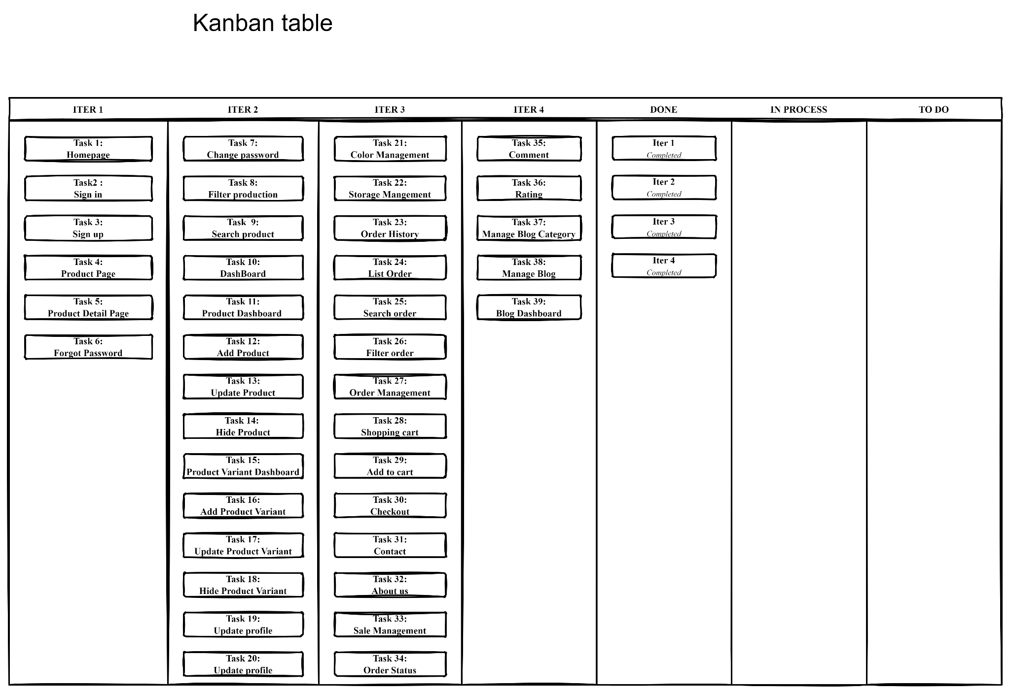

## Burndown Chart

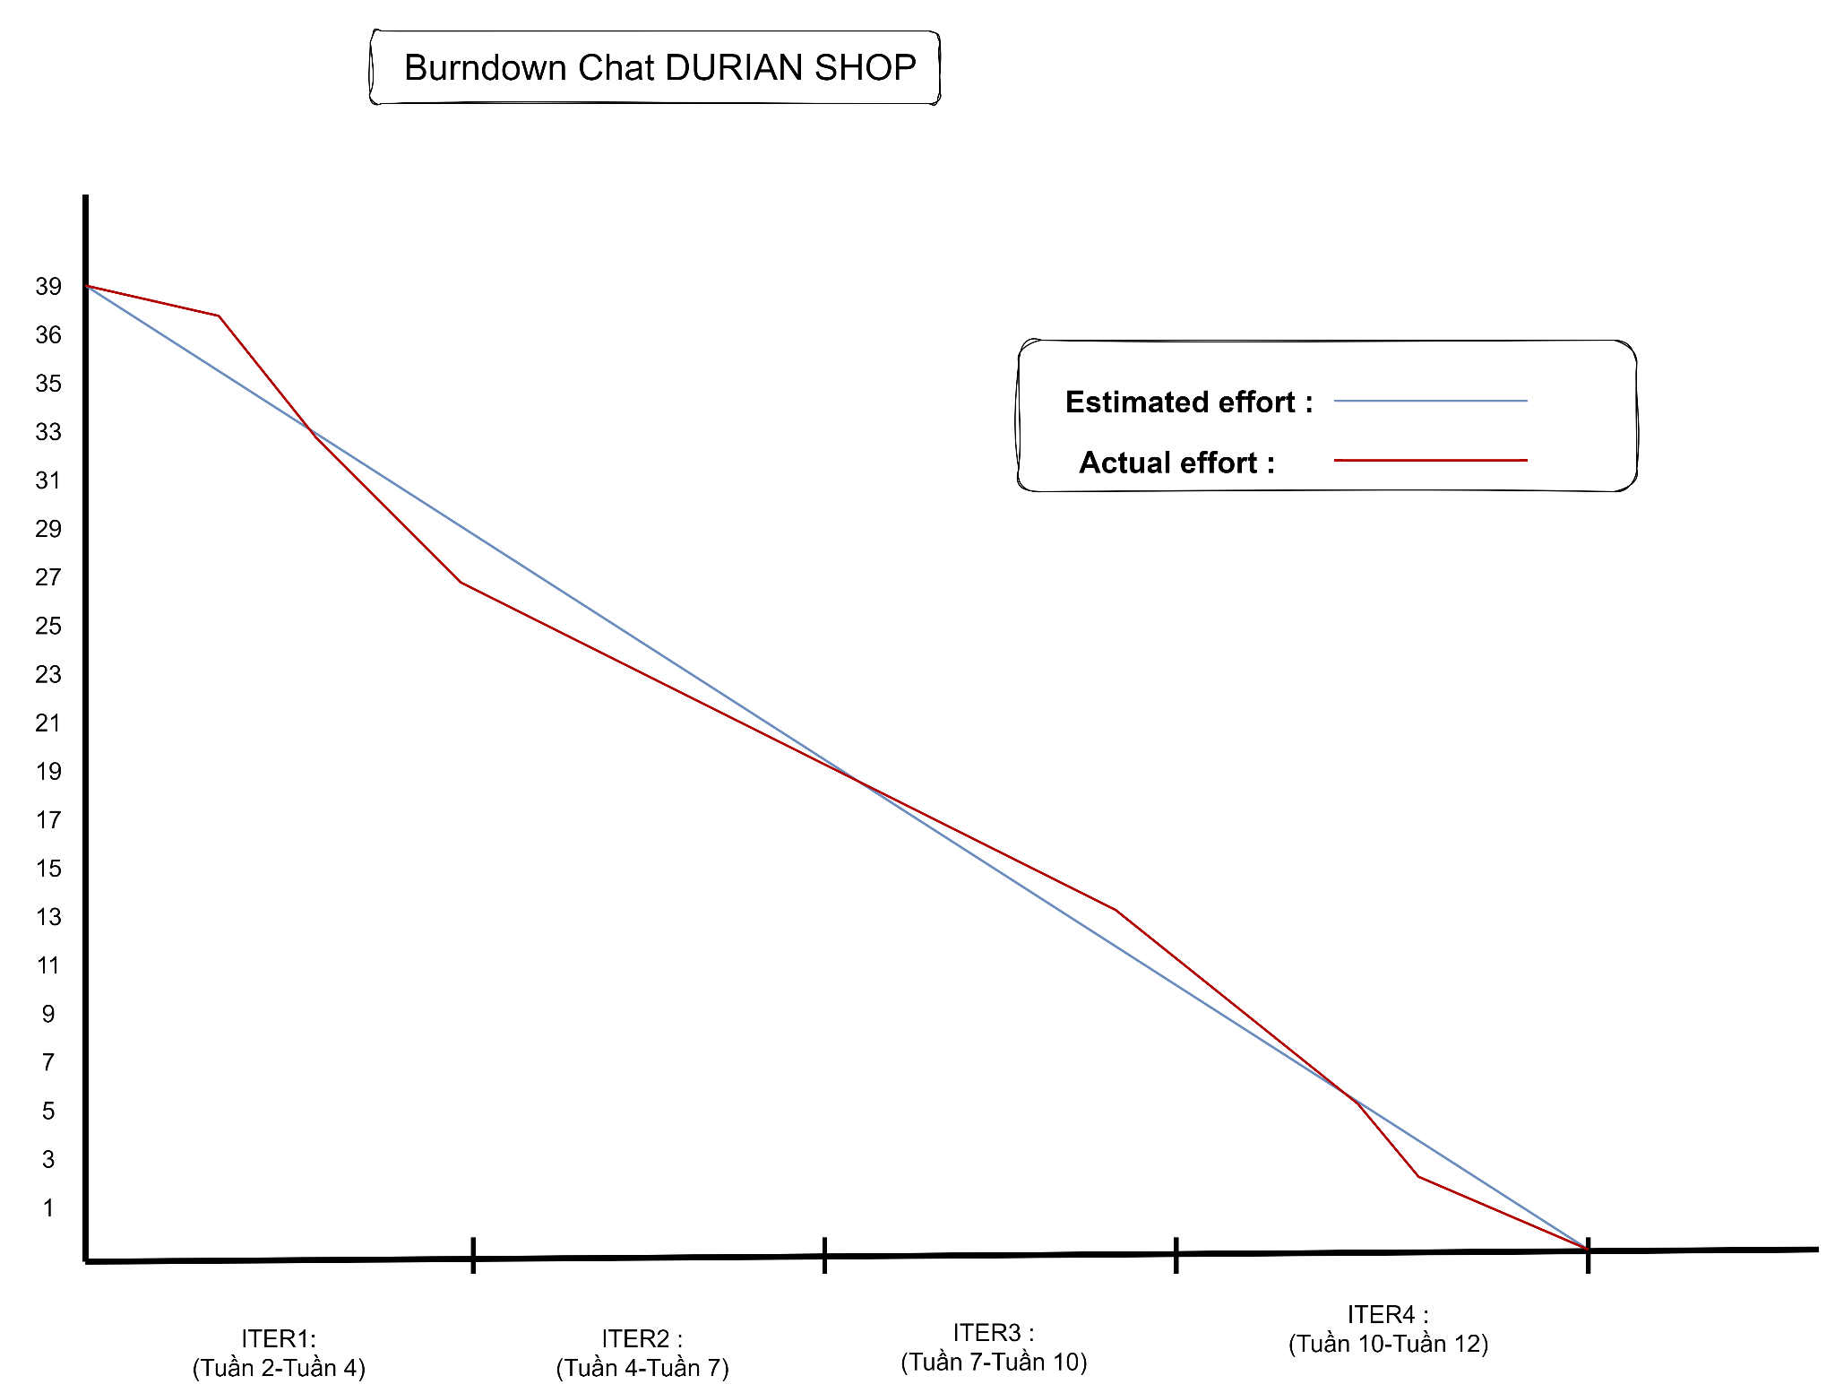

## Road map

## 